**Introduction**

Ebola virus disease (EVD), formerly known as Ebola haemorrhagic fever, is a severe, often fatal illness in humans. The virus is transmitted to people from wild animals and spreads in the human population through human-to-human transmission. The average EVD case fatality rate is around 50%. Case fatality rates have varied from 25% to 90% in past outbreaks.

The first EVD outbreaks occurred in remote villages in Central Africa, near tropical rainforests, but the most recent outbreak in West Africa has involved major urban as well as rural areas.

Community engagement is key to successfully controlling outbreaks. Good outbreak control relies on applying a package of interventions, namely case management, surveillance and contact tracing, a good laboratory service, safe burials and social mobilisation. Early supportive care with rehydration, symptomatic treatment improves survival. There is as yet no licensed treatment proven to neutralise the virus but a range of blood, immunological and drug therapies are under development.

There are currently no licensed Ebola vaccines but 2 potential candidates are undergoing evaluation.

1. **Ebola haemorrhagic fever in Zaire, 1976**

Between 1 September and 24 October 1976, 318 cases of acute viral haemorrhagic fever occurred in northern Zaire. The outbreak was centred in the Bumba Zone of the Equateur Region and most of the cases were recorded within a radius of 70 km of Yambuku, although a few patients sought medical attention in Bumba, Abumombazi, and the capital city of Kinshasa, where individual secondary and tertiary cases occurred. There were 280 deaths, and only 38 serologically confirmed survivors.

This syndrome was caused by a virus morphologically similar to Marburg virus, but immunologically distinct. It was named Ebola virus.

1. **Ebola outbreak in Democratic Republic of the Congo (formerly Zaire) in 1995**

In May 1995, an international team characterized and contained an outbreak of Ebola hemorrhagic fever (EHF) in Kikwit, Democratic Republic of the Congo. Active surveillance was instituted using several methods, including house-to-house search, review of hospital and dispensary logs, interview of health care personnel, retrospective contact tracing, and direct follow-up of suspect cases. In the field, a clinical case was defined as fever and hemorrhagic signs, fever plus contact with a case-patient, or fever plus at least 3 of 10 symptoms. A total of 315 cases of EHF, with an 81% case fatality, were identified, excluding 10 clinical cases with negative laboratory results. The earliest documented case-patient had onset on 6 January, and the last case-patient died on 16 July. Eighty cases (25%) occurred among health care workers. Two individuals may have been the source of infection for >50 cases. The outbreak was terminated by the initiation of barrier-nursing techniques, health education efforts, and rapid identification of cases.

**Analysis Questions**

1. **Situation analysis by sex and age group**
2. **Analysis of the fatality rate in both the outbreaks**

**Data**

* Following is the age and sex distribution of the cases encountered during 1976 outbreak of Ebola in Zaire.

|  |  |  |
| --- | --- | --- |
| AGE | MALE | FEMALE |
| 0-1 | 10 | 14 |
| 0-14 | 18 | 22 |
| 15-29 | 31 | 60 |
| 30-49 | 57 | 52 |
| 50-89 | 25 | 29 |
|  |  |  |

* Following data describes the number of cases reported and deaths occurred during the outbreaks of 1976 and 1995 of Ebola in Zaire.

|  |  |  |
| --- | --- | --- |
| YEAR OF OUTBREAK | CASE REPORTED | DEATHS |
| 1976 | 318 | 280 |
| 1995 | 315 | 254 |
|  |  |  |

* Following data describes about the major symptoms and the frequency of cases suffered this symptoms in 1995 outbreak of Ebola in Zaire.

|  |  |
| --- | --- |
| SYMPTOMS | CASES |
| Headache | 160 |
| Nausea | 154 |
| Anorexia | 159 |
| Diarrhea | 162 |
| Asthenia | 170 |
| Abdominal pain | 123 |
| Myalgia | 111 |
| Dysphagia | 89 |
| Dyspnea | 55 |
| Hiccups | 32 |
| Gingival hemorrhage | 46 |
| Conjunctival inflammation | 75 |
| Petechiae | 33 |
| Melena | 30 |
| Hematemesis | 28 |

* Following table describes the region wise spread of Ebola in Zaire in 1995.

|  |  |
| --- | --- |
| Regions | Cases |
| Kikwit | 262 |
| Kwilu | 45 |
| Kwango | 1 |
| Other | 7 |

**Model and Analysis**

We have implemented few analytical model as well predicted few values using the above mentioned data and R programming.

* **Fatality analysis:**

Based on the records available for the outbreak of 1976 and 1995, we measured the degree of fatality of each out break.

It was concluded that the outbreak of 1976 was more fatal than the one in 1995. Hence, leading to more deaths out of the people suffered Ebola. If we closely examine, there are many reasons for the first outbreak to be fatal.

Firstly, it spread to a larger region. Since, this was the first time Zaire was encountering Ebola, the awareness was too less regarding the epidemic.

Secondly, the medical support was less compared to 1995 leading to more deaths.

Hence, 1976 outbreak saw more deaths.

* **Sex and age group analysis**

This modeling and analysis gave us a clear picture of the age groups and the gender which got affected at different levels. Studies and analysis shows that women in the middle age group got affected the most. This could be related to the immunity level of this age group of women.

Children also got affected significantly. Similarly, women got affected more compared to men.

* **Predicting the source of infection in 1995**

Based on the records generated from different regions, it shows that Kikwit was the major center of infection and then propagated further**.**

* **Major symptoms of the disease analysis**

Based on the cases registered, we discovered few major symptoms during the epidemic. To mention few:

|  |
| --- |
| 1. Headache |
| 1. Nausea |
| 1. Anorexia |
| 1. Diarrhea |
| 1. Asthenia |

**Conclusion**

**1976:**

Between 1 September and 24 October 1976, 318 cases of acute viral haemorrhagic fever occurred in northern Zaire. The outbreak was centred in the Bumba Zone of the Equateur Region and most of the cases were recorded within a radius of 70 km of Yambuku, although a few patients sought medical attention in Bumba, Abumombazi, and the capital city of Kinshasa, where individual secondary and tertiary cases occurred. There were 280 deaths, and only 38 serologically confirmed survivors.

**1995:**

An outbreak of Ebola hemorrhagic fever (EHF) began in the winter of 1995 in the city of Kikwit in Zaire (now the Democratic Republic of the Congo), but was not recognized until May, when serum samples were sent for diagnosis to the U.S. Centers for Disease Control and Prevention. There is no known drug treatment or vaccine for EHF, which is caused by a filovirus that is transmitted through contact with bodily fluids. By April, poorly equipped and understaffed hospitals in Kikwit and the nearby town of Mosango had become the foci for infection.

The outbreak affected 315 people, and had a fatality rate of 81%. Nearly every case was traced back to an infected family member, friend, or health worker who had been in direct contact with the index patient, or who had experienced a needle stab or undergone surgery. Although the index case of the outbreak was identified, the source of his infection (presumed to be an animal or insect) was not found.

**Overall conclusion**:

For this type of situation, most countries need to revise their preparedness but it is also necessary to find a better system for surveillance and reporting in the countries particularly affected. An international preparedness plan in order to provide efficient and safe help for these specific situations needs to be established.

**Appendix**

Please find below the R code along with the corresponding outputs used for the analysis:

################# sex and age group analysis ################################

> age_and_sex_distribution <- read.csv("R/pcxts_ebola/age_and_sex_distribution.csv")

> summary(age_and_sex_distribution)

AGE MALE FEMALE

0-1 :1 Min. :10.0 Min. :14.0

0-14 :1 1st Qu.:18.0 1st Qu.:22.0

15-29:1 Median :25.0 Median :29.0

30-49:1 Mean :28.2 Mean :35.4

50-89:1 3rd Qu.:31.0 3rd Qu.:52.0

Max. :57.0 Max. :60.0

> library(ggplot2)

> library(reshape2)

> d <- melt(age_and_sex_distribution, id.vars="AGE")

# Everything on the same plot

> ggplot(d, aes(AGE,value, col=variable)) +

+ geom_point() +

+ stat_smooth()

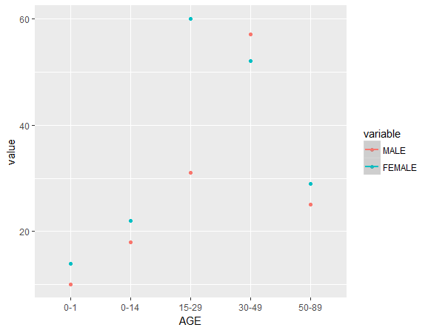

> pie.male<- pie(age_and_sex_distribution$MALE,

+ labels=c("0-1","1-14","15-29","30-49","50-89"),main="Age-wise distribution of cases of Ebola in male"

+ )

> pie.female<- pie(age_and_sex_distribution$FEMALE,

+ labels=c("0-1","1-14","15-29","30-49","50-89"),main="Age-wise distribution of cases of Ebola in female"

+ )

> pie.female<- pie(age_and_sex_distribution$FEMALE,

+ labels=c("0-1","1-14","15-29","30-49","50-89"),main="Age-wise distribution of cases of Ebola in female"

+ )

> pie.female<- pie(age_and_sex_distribution$FEMALE,

+ labels=c("0-1","1-14","15-29","30-49","50-89"),main="Age-wise distribution of cases of Ebola in female"

+ )

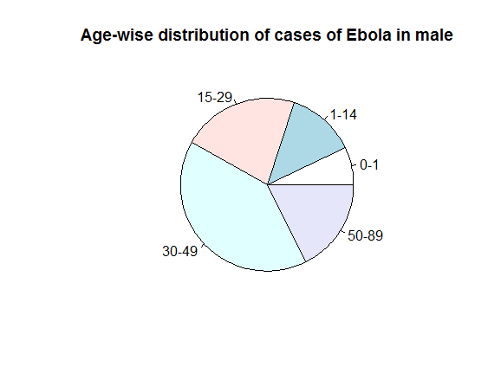

> pie.female<- pie(age_and_sex_distribution$FEMALE,

+ labels=c("0-1","1-14","15-29","30-49","50-89"),main="Age-wise distribution of cases of Ebola in female"

+ )

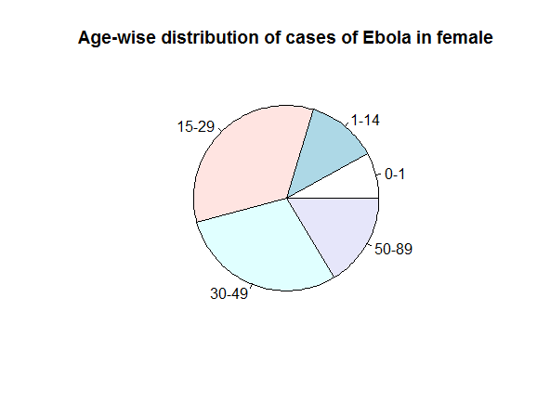

############# fatality analysis ########################

> fatality_comparision <- read.csv("R/pcxts_ebola/fatality.csv")

> summary(fatality_comparision)

YEAR.OF.OUTBREAK CASE.REPORTED DEATHS

Min. :1976 Min. :315.0 Min. :254.0

1st Qu.:1981 1st Qu.:315.8 1st Qu.:260.5

Median :1986 Median :316.5 Median :267.0

Mean :1986 Mean :316.5 Mean :267.0

3rd Qu.:1990 3rd Qu.:317.2 3rd Qu.:273.5

Max. :1995 Max. :318.0 Max. :280.0

#fatality rate of outbreak of ebola in 1976

> fatality_comparision$DEATHS[1]/fatality_comparision$CASE.REPORTED[1] *100

[1] 88.05031

#fatality rate of outbreak of ebole in 1995

> fatality_comparision$DEATHS[2]/fatality_comparision$CASE.REPORTED[2] *100

[1] 80.63492

# Hence, the outbreak of 1976 was more fatal than that of 1995

#################### predicting the source of infection based on cases reported from different regions in 1995 ########

> regions_1995 <- read.csv("R/pcxts_ebola/regions_1995.csv")

> regions_1995

Regions Cases

1 Kikwit 262

2 Kwilu 45

3 Kwango 1

4 Other 7

> barplot(regions_1995$Cases,names.arg = regions_1995$Regions)

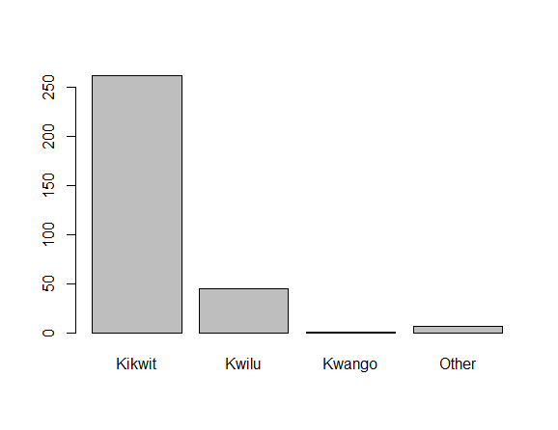

# this shows that Kikwit the principal foci of infection and source of secondary case-patients.

######################## major symptoms analysis for 1995 #################

> symptoms_1995 <- read.csv("R/pcxts_ebola/Major_symptoms_1995.csv")

> symptoms_1995

SYMPTOMS CASES

1 Headache 160

2 Nausea 154

3 Anorexia 159

4 Diarrhea 162

5 Asthenia 170

6 Abdominal pain 123

7 Myalgia 111

8 Dysphagia 89

9 Dyspnea 55

10 Hiccups 32

11 Gingival hemorrhage 46

12 Conjunctival inflammation 75

13 Petechiae 33

14 Melena 30

15 Hematemesis 28

> symptoms_1995<-cbind(symptoms_1995,percentage=symptoms_1995$CASES/315*100)

> head(symptoms_1995,decreasing=TRUE)

SYMPTOMS CASES percentage

1 Headache 160 50.79365

2 Nausea 154 48.88889

3 Anorexia 159 50.47619

4 Diarrhea 162 51.42857

5 Asthenia 170 53.96825

6 Abdominal pain 123 39.04762

# these seem to be the major symptoms during the outbreak in 1995s