AMERICAN COMPUTER SCIENCE LEAGUE
2001 - 2002

All-Star

JUNIOR DIVISION

1. RECURSIVE FUNCTIONS
Find f (9,4)
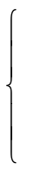
f (x - 2, 2y + 1) if x > 6
f (x – 3, y – 1) + 2 if 2 ≤ x ≤ 6
2x – y otherwise
f (x,y) =

A) –15 B) –13 C) –6 D) –2 E) NOT LISTED

- COMPUTER NUMBER SYSTEMS

Convert 0.9C6₁₆ to a base 10 proper fraction reduced to lowest terms.

A) 1/2 B) 1/40 C) 5/256 D) 625/1024 E) NOT LISTED

- DIGITAL ELECTRONICS

Write a simplified Boolean expression for the following circuit:

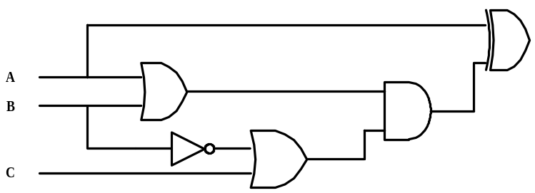

A) A B) AB C) ABC D) B(A⊕C) E) NOT LISTED

- EXPRESSION TRANSLATION

What is the minimum number of sets of parentheses needed to translate the following expression:

1 + 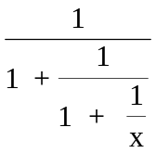

A) 0 B) 1 C) 2 D) 3 E) NOT LISTED

AMERICAN COMPUTER SCIENCE LEAGUE
2001 - 2002

All-Star

JUNIOR DIVISION

- WHAT DOES THIS PROGRAM DO?

After the program segment is executed, what is the final value of F. The program starts with array A configured as follows with A(1,1) = 4:

4 | 0 | 1
8 | 6 | 3
3 | 3 | 0
M = 3: F = 0
FOR C = 1 TO M
D = 1: U = -1: N = C
FOR R = 1 TO M
D = D ∗ A(R, N)
U = U ∗ A (M – R + 1, N)
IF N = M THEN N = 1 ELSE N = N + 1
NEXT R
F = F + D + U
NEXT C

A) 10 B) –20 C) –30 D) 40 E) NOT LISTED

6. BOOLEAN ALGEBRA
How many ordered triplets make the following expression FALSE?

(NOT (NOT A OR B)) AND (B AND NOT C)

A) 0 B) 2 C) 4 D) 8 E) NOT LISTED

7. PREFIX/INFIX/POSTFIX
Definitions: a!b = Greatest Common Factor (GCF) of a and b. a#b = Least Common Multiple (LCM ) of a and b. Evaluate the following prefix expression:

↑ / * ! 12 18 # 2 3 ↑ ! 6 8 2 ! 9 15

A) 27 B) 64 C) 125 D) 729 E) NOT LISTED.

8. DATA STRUCTURES
Insert the letters in TESSELLATIONS into an initially empty binary search tree. What is the external path length?

A) 72 B) 46 C) 23 D) 43 E) NOT LISTED

