AMERICAN COMPUTER SCIENCE LEAGUE
2001 - 2002

All-Star

SENIOR DIVISION

1. RECURSIVE FUNCTIONS
Find f (9,4)
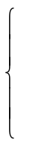
f (x - 2, 2y + 1) if x > 6
f (x – 3, y – 1) + 2 if 2 ≤ x ≤ 6
2x – y otherwise
f (x,y) =

A) –15 B) –13 C) –6 D) –2 E) NOT LISTED

2. COMPUTER NUMBER SYSTEMS
Convert 0.9C6₁₆ to a base 10 proper fraction reduced to lowest terms.

A) 1/2 B) 1/40 C) 5/256 D) 1251/2048 E) NOT LISTED

3. BIT- STRING FLICKING
Solve for X, a 5-bit string.

(RCIRC – 3 (LSHIFT – 1 (01011 AND X ))) XOR (RSHIFT – 2 (LCIRC – 1 (10111 OR X ) )) = 10101

A) *1111 B) 10001 C) 10*10 D) 11001 E) NOT LISTED

4. DATA STRUCTURES
Insert the letters in TESSELLATIONS into an initially empty binary search tree. What is the external path length?

A) 72 B) 46 C) 23 D) 43 E) NOT LISTED

5. GRAPH THEORY
How many paths of length 3 exist in the following directed graph?
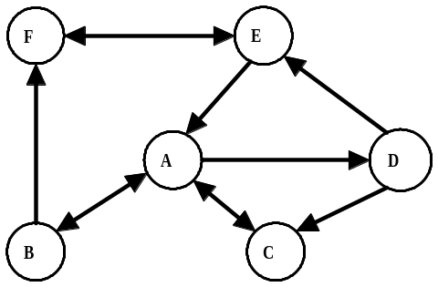

A) 37 B) 39 C) 40 D) 45 E) NOT LISTED

AMERICAN COMPUTER SCIENCE LEAGUE
2001 - 2002

All-Star

SENIOR DIVISION

- DIGITAL ELECTRONICS
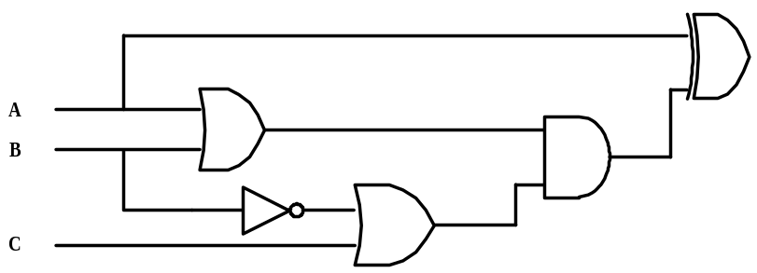Write a simplified Boolean expression for the following circuit:

A) A B) AB C) ABC D) B( A⊕C) E) NOT LISTED

7. BOOLEAN ALGEBRA
How many ordered triplets make the following expression FALSE?

(NOT (NOT A OR B)) AND (B AND NOT C)

A) 0 B) 2 C) 4 D) 8 E) NOT LISTED

8. EXPRESSION TRANSLATION
What is the minimum number of sets of parentheses needed to translate the following expression:

1 + 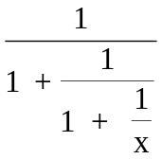

A) 0 B) 1 C) 2 D) 3 E) NOT LISTED

9. LISP
Evaluate the following LISP program:

( SETQ X ’((1 ( 2 3 ) 4 ) (( 5 6 ) 7 ) 8 ( 1 3 )))
( CAR ( CDR ( REVERSE ( CDR ( REVERSE X ) ) ) ) )

A) 567 B) ((5 6) 7 ) 8 C) (5 6 7) D) ((5 6 7 )) E) NOT LISTED

10. PREFIX/INFIX/POSTFIX
Definitions: a!b = Greatest Common Factor (GCF) of a and b. a#b = Least Common Multiple (LCM) of a and b. Evaluate the following prefix expression:

↑ / * ! 12 18 # 2 3 ↑ ! 6 8 2 ! 9 15

A) 27 B) 64 C) 125 D) 729 E) NOT LISTED.

AMERICAN COMPUTER SCIENCE LEAGUE
2001 - 2002

All-Star

SENIOR DIVISION

11. ASSEMBLY LANGUAGE
Given inputs of 19 and 82, what is the final value of SUM?
The Assembly Language operators AND, LSHIFT and RSHIFT use the data from the ACC and store the result in the ACC. The Assembly Language operators are executed on the binary representation of the decimal numbers. If the ACC contained 37, the instruction AND =1 would cause a value of 1 (100101 AND 1 = 000001) to be stored in the ACC. RSHIFT = 1 executed on 37 would cause a value of 18 (RSHIFT-1 100101 = 10010) to be stored in the ACC. LSHIFT = 1 executed on 37 would produce a value of 74 (LSHIFT-1 100101 = 1001010) to be stored in the ACC. Note the left most digit is not deleted but moves left to the next place value and a zero is added on the right.

SUM DC 0 EVEN LOAD A
READ A RSHIFT =1
READ B STORE A
LOAD A LOAD B
TOP AND =1 LSHIFT =1
BE EVEN STORE B
LOAD SUM LOAD A
ADD B BG TOP
STORE SUM END

A) 2624 B) 246 C) 1312 D) 1558 E) NOT LISTED

- What Does This Program Do?
After the program segment is executed, what is the final value of F. The program starts with array A configured as below and with A(1,1) = 4

4 | 0 | 1
8 | 6 | 3
3 | 3 | 0
M = 3: F = 0
FOR C = 1 TO M
D = 1: U = -1: N = C
FOR R = 1 TO M
D = D ∗ A(R, N)
U = U ∗ A (M – R + 1, N)
IF N = M THEN N = 1 ELSE N = N + 1
NEXT R
F = F + D + U
NEXT C

A) 10 B) –20 C) –30 D) 40 E) NOT LISTED

