American Computer Science League
2001-2002

Contest #2

Intermediate Division Short Problems

1. Computer Number Systems

Solve for X₂

X₂ = A12₁₆ − 567₈

- Boolean Algebra

Simplify completely

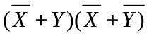

- Boolean Algebra

List all ordered triples (A,B,C) that make the following
expression FALSE

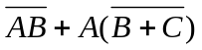

4. Bit String Flicking

Evaluate

(RSHIFT−2 (RCIRC−8 (RSHIFT−2 (10011) ))

5. Bit String Flicking

How many values of X (5 bits long) satisfy the following equation?

(RSHIFT−1 X ) OR 10110 AND 00101 = 00101

