American Computer Science League
2001-2002

Contest #2

Intermediate Division Solutions

1. Change 567₈ to hexadecimal and subtract. A12₁₆ − 177₁₆ = 89B₁₆. 1. 100010011011₂.
89B₁₆ converts to 100010011011₂.

2. 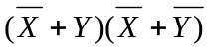 = 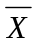 + + + = + + + 0= 2.
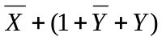= 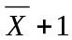=

3. 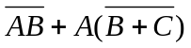= 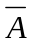 + 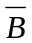+  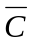= 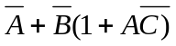= 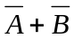= 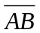 3. (1,1,1) and (1,1,0)
Now if 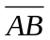=0, then =1 which implies 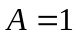and 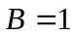.
Therefore, the solution is in the form (1,1,∗)

- Working from the inside out: 4. 00100

RSHIFT−2 10011 = 00100
RCIRC−8 00100 = RCIRC−3 00100 = 00001
RSHIFT−2 00001 = 00100

- Let X = abcde. 5. 4
RSHIFT−1 abcde = 0abcd
0abcd OR 10110 AND 00101 = 00101
Since AND has precedence over OR
10110 AND 00101 = 00100
0abcd OR 00100 = 00101
Evaluating one bit at a time gives:
a OR 0 = 0 implies a = 0
b OR 1 = 1 implies b = ∗
c OR 0 = 0 implies c = 0
d OR 0 = 0 implies d = 1
e = ∗
The 4 solutions take the form (0, ∗ , 0, 1, ∗)

