American Computer Science League
2001-2002

Contest #3

Intermediate Division Short Problems

1. Digital Electronics
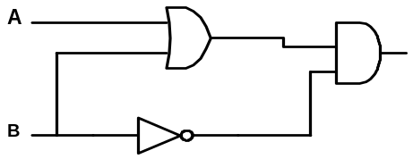 Find all ordered pairs (A,B) that make the following circuit TRUE.

- Digital Electronics
Translate the circuit to a Boolean expression and simplify.
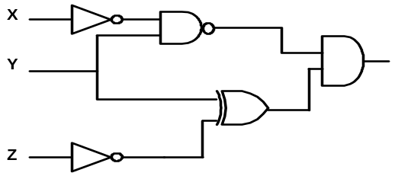
- Boolean Algebra
Simplify so that only AND and NOT symbols are used

A ( B + C ) + B ( A + C ) + C (A + B )

- 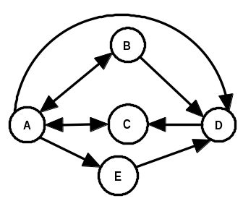Graph Theory
Which of the following are simple paths in the following diagram?
- ECAD
- BCABD
- EDCAB
- CADCB
- None of the above

5. Graph Theory
Write the adjacency matrix for the following graph.
