American Computer Science League
2001-2002

Contest #4

Intermediate Division Short Problems

- 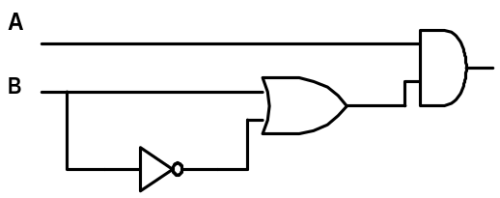Digital Electronics

List all of the following statements that are true about the circuit above.
- It is TRUE for all possible inputs.
- It is FALSE for all possible inputs
- It is TRUE only when the two inputs are different.
- It is sometimes TRUE when the two inputs are different.
- It is FALSE whenever B is TRUE.

- Prefix/Postfix
Convert the following postfix expression into prefix.

AAB + CAB / - / *

- Prefix/Postfix
The volume of a sphere is given by the formula V= 4/3 π R ³. Translate
the formula, as written above, into prefix.

- Data Structures
Consider the following operations on an initially empty queue. If a POP
is now performed, what value would be popped?
PUSH (B) PUSH (D)
PUSH (I) POP (X)
PUSH (N) PUSH (S)
POP (X) POP (X)
5. Data Structures
Insert the key “VULCAN” into the following binary search tree.
What is the new external path length?
PLUTO
MARS
SATURN
EARTH
MERCURY
VENUS
NEPTUNE

