American Computer Science League
2001-2002

Contest #2

Junior Division Short Problems

1. What Does This Program Do - Looping

When the following program is run with X = 20, what is the
final value of C?

10 C = 0
20 D = X – 1
30 IF X/D <>INT (X / D ) THEN D = D - 1 ELSE C = D
40 IF C = 0 THEN GOTO 30
50 END

- Boolean Algebra

Simplify completely

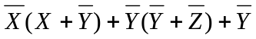

- Boolean Algebra

List all ordered pairs (A, B) that make the following expression
TRUE.

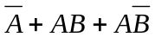

- Bit String Flicking

Evaluate

(LSHIFT− 2 (LCIRC− 2 (RSHIFT − 1 10100 )))

- Bit String Flicking

How many different values of X (5 bits long) satisfy the following
equation?

00110 OR X = 10110

