American Computer Science League
2001-2002

Contest #2

Junior Division Solutions

1. This program finds the largest factor of X, less than X, by counting 1. 10
counting down from X until it finds a factor. The loop ends when
C changes from zero.

2.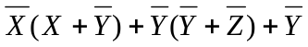=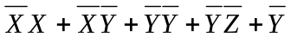= 2.
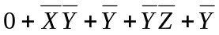 = 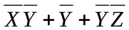= 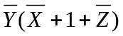 =

3. 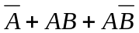= 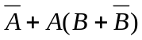= 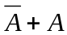= 1. The 1 denotes that the 3. (1,1), (1,0), (0,1),
expression is always TRUE. All 4 possible inputs must be listed. (0,0)

- Working from the inside out: 4. 00100
RSHIFT−1 10100 = 01010
LCIRC−2 01010 = 01001
LSHIFT−2 01001 = 00100

- Let X=abcde. The equation becomes 00110 OR abcde = 10110. 5. 4
Consider the equation bit by bit.
0 OR a = 1 implies a = 1
0 OR b = 0 implies b = 0
1 OR c = 1 implies c can be either a 1 or a 0
1 OR d = 1 implies c can be either a 1 or a 0
0 OR e = 0 implies e = 0
(1, 0, ∗, ∗ , 0) gives 4 possible solutions

