American Computer Science League
2001-2002

Contest #3

Junior Division Short Problems

1. What Does This Program Do - Looping
When the following program is run, what is the last element of
array B that is modified?
FOR J =5 TO 1 STEP –1
FOR K = 3 TO 10 STEP 2
B(J,K) = J + K
NEXT K
NEXT J

- Digital Electronics
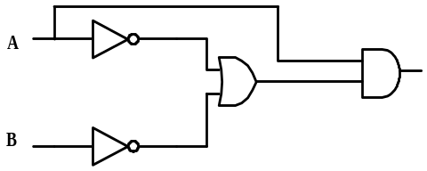Write the Boolean expression that is the exact translation of
the following circuit:

- Digital Electronics
Find all ordered triplets (A,B,C) that make the following circuit
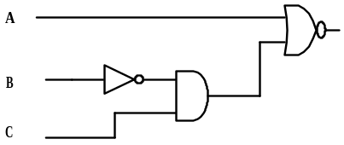TRUE.

- Graph Theory
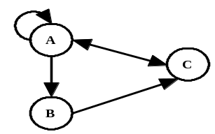How many different paths of length 2 exist in the following
directed graph?
5. Graph Theory
How many cycles exist in the following directed graph?

