American Computer Science League
2001-2002

Contest #4

Junior Division Solutions

- What Does This Program Do?
LEN (B$) = 100 1. 138
LEN (MID$(A$,52,12)) = 12
LEN (MID$(B$,26,13)) = 13
LEN (C$) = 12 + 13 = 25
LEN (D$) = 13
LEN (E$) = 100 + 25 + 13 = 138

2. Prefix-Infix-Postfix
A ( B + D ) / ( C – E ) translates as follows: 2. ABD + * C E - /
A * (B + D ) / ( C – E ) = A * (B D + ) / ( C – E) =
( A B D + * ) / ( C E - ) = ABD + * C E - /

- Prefix-Infix-Postfix
Converting + - + A * B C + A C C to infix gives: 3. 32
+ - + A (B * C) (A + C) C = ((A + B C ) – ( A + C ) ) + C =
( A + B C ) – ( A + C ) + C . Substituting the given values gives:
(2 + 4 * 8) – ( 2 + 8 ) + 8 = 34 – 10 + 8 = 32

4. Data Structures

The tree is formed as shown and has an internal path length of 13. 4. 13
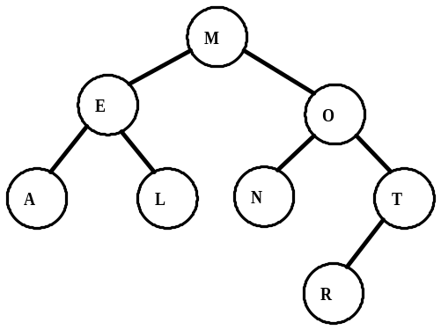13 = 2(1) + 4(2) + 3

5. Data Structures
A stack processes commands in LIFO order (Last In – First Out). 5. D
The five items POPPED in order are B, C, A, F and E. The only item
left in the stack is D.

