American Computer Science League
2001-2002

Contest #3

Senior Division Short Problems

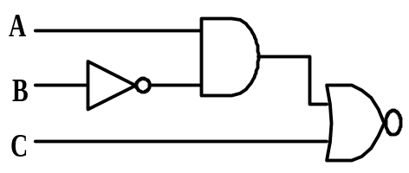 1. Digital Electronics
Find all ordered triples (A,B,C) that make the circuit TRUE.

- Digital Electronics

Suppose that B is always FALSE. Find a simplified Boolean
expression for the circuit.
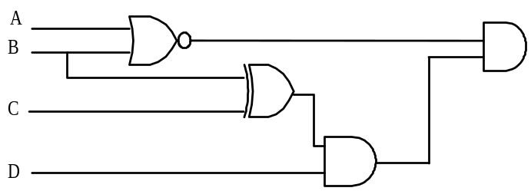

- Boolean Algebra
Simplify completely
( A + B ) A B

- Graph Theory
How many 1’s are in the adjacency matrix of the below graph?
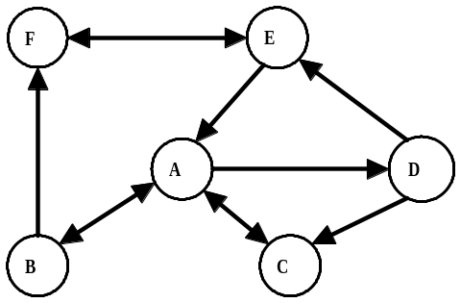

- Graph Theory

A complete, undirected graph is one in which there is an undirected
edge between every pair of distinct vertices. How many edges exist in
a complete, undirected graph with 10 vertices?

