American Computer Science League
2001-2002

Contest #4

Senior Division Short Problems

1. Digital Electronics
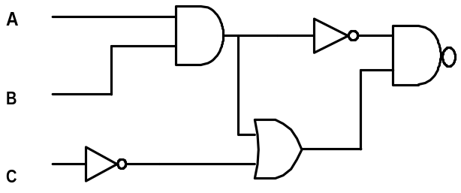Find all ordered triplets (A,B,C) that make the following circuit TRUE.

2. Prefix/Postfix
If A = 7, B = 9, C = 3, D = 4, E = 6, and F =8, evaluate the following
postfix expression:
A B C D E A - + * / + F E - +

3. Prefix/Postfix
Find all integer values of X for which the following prefix expression has
a value of zero:
* + X 4 - 6 X

4. Data Structures
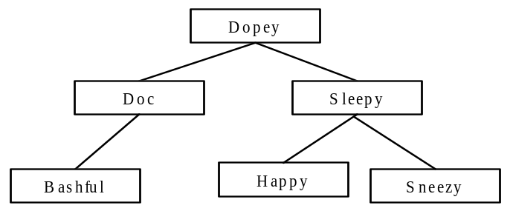When “Grumpy” is inserted into the following binary search tree, what
is the new external path length of the tree?

5. Data Structures
Consider the following operations on an initially empty stack. If a POP
is now performed, what value would be popped?
PUSH (B) PUSH (D)
PUSH (I) POP (X)
PUSH (N) PUSH (S)
POP (X) POP (X)

