American Computer Science League
2003-2004

All-Star

TEST QUESTIONS

1. Digital Electronics
X,Y and Z represent one of the logic gates AND, OR and XOR. The last column of the truth table for the diagram, using the standard ACSL inputs, contains in order:
0, 0, 1, 0, 1, 1, 1, 0.
X, Y and Z must be what logic gates?
1
A. AND, OR , XOR
B. AND, XOR, OR
C. OR, AND, XOR
D. XOR, AND, OR
E. None of the above

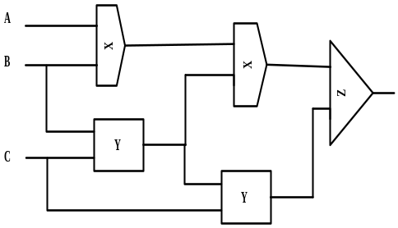

2.
A. 2
B. 3
C. 4
D. 5
E. None of the above

2. Recursive Functions
Find f (4,5)

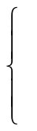
f ( f (y -3, x -2 ) , f (y-1, x) ) if x > 1
x - y if x ≤ 1
f (x,y) =

3.
A. .204₈
B. .24₈
C. .102₈
D. .51₈
E. None of the above
3. Computer Number Systems

Convert .42₁₆ to octal

4. Data Structures
4.
A. 0
B. 1
C. 2
D. 3
E. None of the above

Construct a binary search tree with the letters CHICAGOILLINOIS.
Perform an INORDER, PREORDER and POSTORDER transversal of the
tree. Put the letters found, in order, into a row of a 3 x 15 array. How
many columns have all three letters the same?

American Computer Science League
2003-2004

All-Star

TEST QUESTIONS

5. Graph Theory 5.
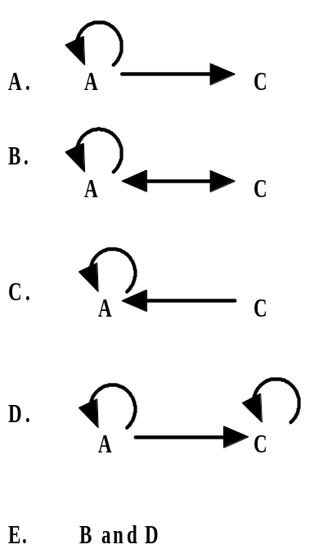
Given the following adjacency matrix, which of the listed changes
would produce the most paths of length 2.

 | A | B | C | D
A | 1 | 1 | 0 | 0
B | 0 | 0 | 1 | 0
C | 0 | 1 | 0 | 1
D | 0 | 0 | 1 | 0

6. Bit String Flicking
6.
A. 00001
B. 10000
C. 10100
D. 00000
E . None of the above

Solve for X, where X is a 5-bit string:

(RSHIFT-3 00101) OR (LCIRC-2 X) =
NOT(LSHIFT-2 10111) AND (RCIRC-1 X)

7.
A. 2
B. 4
C. 5
D. 7
E. None of the above

7. Boolean Algebra

How many ordered triples make the following expression FALSE?

American Computer Science League
2003-2004

All-Star

TEST QUESTIONS

8. FSA’s and Regular Expressions
8.
A. 0
B. 1
C. 2
D. 4
E. None of the above

What is the difference between the longest and shortest strings that
contain exactly 6 1’s.

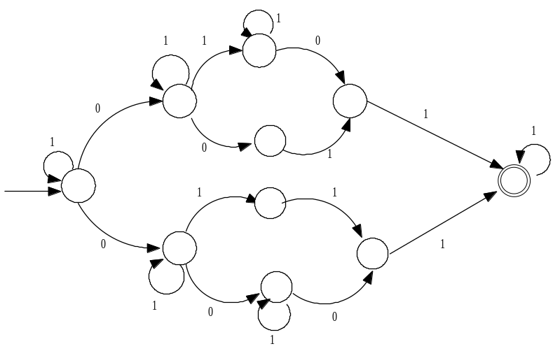

9. LISP
9.
A. 2 3
B (( 2 3 ))
C. ( 2 3 )
D. ( 0 2 3 )
E. None of the above

There is a shortcut for writing repeated CAR and CDR functions
on a list x. (CAADAR x) produces (CAR(CAR(CDR(CAR x)))).
Evaluate the following:

(CDADDAAR ’(((0 1 (0 (2 3 )) (4 5)) 3) (4 5 (6 7)) (0 1 (2 3))))

10. Prefix/Infix/Postfix
10.
A. 8
B. 10
C. 12
D. 14
E. None of the above

Let # represent the unary operator that is equivalent to ABS(x), the
absolute value of x. Let ! represent the unary operator that is equivalent
to INT(x), the largest integer less than or equal to x. Let % represent
the binary operator that is equivalent to AVG(x), the mean of x.
Evaluate the following prefix expression:

+ ! % # - 2 4 # / * 3 2 6 ! % 3 8

American Computer Science League
2003-2004

All-Star

TEST QUESTIONS

11. Assembly Language Programming
11.
A. 2
B. 3
C. 4
D. 5
E. None of the above

When the following program is run, how many unique values are
printed?
X DC 6
Y DC 4
Z DC 0
LOAD X
SUB Y
STORE Z
PRINT Z
LOAD Y
SUB =2
STORE Y
PRINT X
LOAD Z

ADD =2
STORE X
SUB Z
PRINT Y
STORE X
PRINT X
ADD Z
ADD X
STORE X
PRINT X

12.
A. 5
B. 3
C. 2
D. 1
E. None of the above
12. What Does This Program Do?

How many times is the PRINT statement executed when the
following program is RUN?

FOR A = 1 to 9
FOR E = 0 to 9
FOR T = 1 to 2
IF (10*A + T) + A = 100*T + 10*E + E THEN PRINT A,T,E
NEXT T
NEXT E
NEXT A
END

