American Computer Science League
2003-2004

Contest #2

Intermediate Division Short Problems

1. Computer Number Systems
Convert the following hex value to a base 10 value.

.3A₁₆ = X₁₀

2. Boolean Algebra
Find all ordered pairs that make the following expression TRUE.

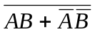

- Boolean Algebra
Simplify the following expression.

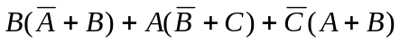

4. Bit String Flicking
Evaluate the following expression.

(NOT (RSHIFT-1 (RCIRC-2 ( NOT (LSHIFT-1 01101) ) ) ) )

5. Bit String Flicking

How many different values of X (a 5-bit string) satisfy the
following expression.

( RCIRC-3 10101 OR LCIRC-2 X) = 10111

