American Computer Science League
2003-2004

Contest #2

Intermediate Division Solutions

1. 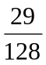
1. Computer Number Systems
.3A₁₆ = 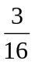 + 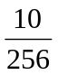= 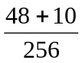= 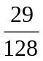

2. Boolean Algebra
2. (0,1) and (1,0)

 |  |  | 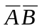 | + | 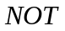
0 | 0 | 0 | 1 | 1 | 0
0 | 1 | 0 | 0 | 0 | 1
1 | 0 | 0 | 0 | 0 | 1
1 | 1 | 1 | 0 | 1 | 0

- Boolean Algebra
3. A + B
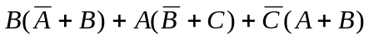=
= 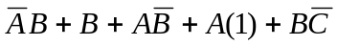 = 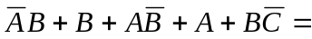
= 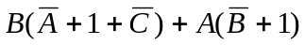= 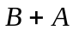

4. Bit String Flicking
4. 11011
(NOT (RSHIFT-1 (RCIRC-2 ( NOT (LSHIFT-1 01101) ) ) ) )
(LSHIFT-1 01101) = 11010
(NOT 11010) = 00101
(RCIRC-2 00101) = 01001
(RSHIFT-1 01001) = 00100
(NOT 00100) = 11011

5. Bit String Flicking
5. 8

Let X = ABCDE. Then ( LCIRC-2 X) = CDEBA and
(RCIRC-3 10101) = 10110
 | 1 | 0 | 1 | 1 | 0
OR | C | D | E | A | B
 | 1 | 0 | 1 | 1 | 1

1 OR C = 1 ⇒ C = *
D OR 0 = 0 ⇒ D = 0
1 OR E = 1 ⇒ E = *
1 OR A = 1 ⇒ A = *
B OR 0 = 1 ⇒ B = 1
ABCDE = *1*0* There are 2³ = 8 different values for ABCDE.

