American Computer Science League
2003-2004

Contest #3

Intermediate Division Short Problems

- Digital Electronics

Find all ordered triples that make the following circuit TRUE:
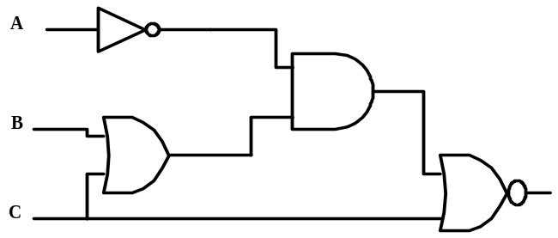

- Digital Electronics

Convert the following diagram to a Boolean expression and simplify

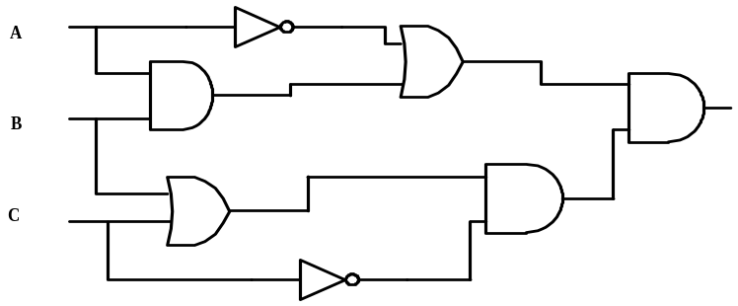

- Graph Theory

Draw the directed graph with vertices {A,B,C,D,E} and edges {AB, DA,
CE, DE,AE, BC, CA}.

- Graph Theory

How many different cycles exist in the directed graph defined in Question #3?

- Boolean Algebra

Simplify the following Boolean expression:

