American Computer Science League
2003-2004

Contest #3

Intermediate Division Solutions

- Digital Electronics
1. (0,0,0)
(1,0,0)
(1,1,0)
The circuit translates to: 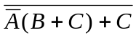

 |  |  | 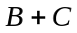 | 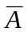 | 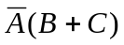 | 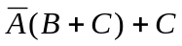 | 
0 | 0 | 0 | 0 | 1 | 0 | 0 | 1
0 | 0 | 1 | 1 | 1 | 1 | 1 | 0
0 | 1 | 0 | 1 | 1 | 1 | 1 | 0
0 | 1 | 1 | 1 | 1 | 1 | 1 | 0
1 | 0 | 0 | 0 | 0 | 0 | 0 | 1
1 | 0 | 1 | 1 | 0 | 0 | 1 | 0
1 | 1 | 0 | 1 | 0 | 0 | 0 | 1
1 | 1 | 1 | 1 | 0 | 0 | 1 | 0

- Digital Electronics
2. 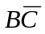
The circuit translates to: 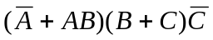
= (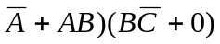=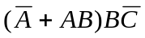= 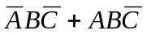
=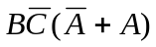= 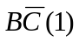=

3. Graph Theory
3. As Shown
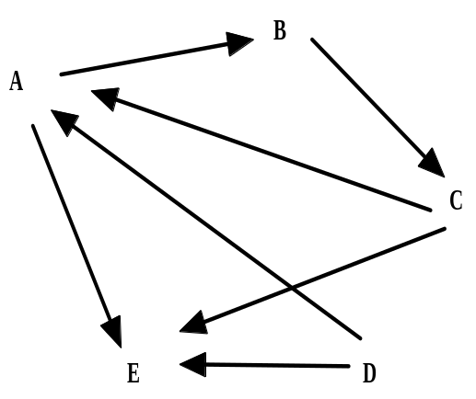

4. Graph Theory
4. 1

There is just one cycle in the graph: ABCA

5. Boolean Algebra
5. 


