American Computer Science League
2003-2004

Contest #4

Intermediate Division Solutions

- Prefix/Infix/Postfix
1. A B + 2 ↑ C A 2 ↑ B + * /

/ ↑ + A B 2 * C + ↑ A 2 B translates to 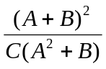 which translates to
A B + 2 ↑ C A 2 ↑ B + * /
2. 13
- Prefix/Infix/Postfix

3 2 ↑ 2 3 * - 2 2 ↑ @ 8 2 – 6 3 / * @ =
(3²) (2 * 3) – (2²) @ (8- 2)(6/3) * @ =
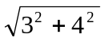@ 12 = 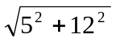= 13
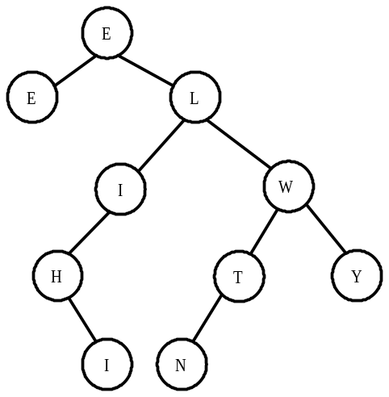
3. Data Structures
3. 3

4. Graph Theory
4. IL
The queue forms as follows:
CH, H, HIC, C, CAG, EMPTY, OI, I, IL

5. Digital Electronics
5. (* , 0, 1)
( 0 , 1 , * )

The circuit converts to Boolean form and simplifies as follows:

=

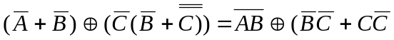)

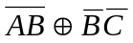must be TRUE
Suppose 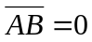 and 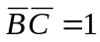. This leads to an impossible situation.

Now suppose 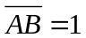and 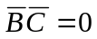
If B=0 then A=* and C=1
If B=1 then A=0 and C=*

