American Computer Science League
2003-2004

Contest #3

Junior Division Short Problems

1. What Does This Program Do – Subscripts

The 3 x 3 array A initially contains the following values: 8,1,6,3,5,7,4,9,2.
A(1,1) = 8, A(1,2 ) = 1, …etc. When the following program is executed, what value is
printed?
X = 0
FOR J = 1 TO 3
FOR K = 1 TO 3
IF A(J,K) / 2 = INT (A(J,K) / 2 ) THEN X=X + A(J,K)
ELSE X = X – A(J,K)
NEXT K
NEXT J
PRINT X

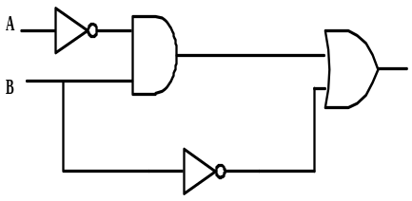
2. Digital Electronics
.
List all the ordered pairs (A,B) that make the following circuit FALSE.

3. Digital Electronics
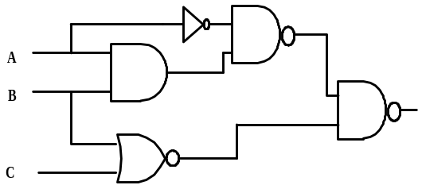
Write the following circuit as a Boolean expression with as few parentheses as possible. Do not simplify.

4. Graph Theory
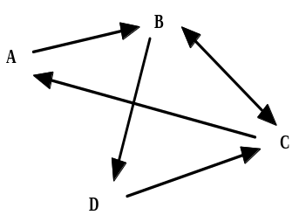
How many paths from A of length 2 exist in the following directed graph?

5. Graph Theory
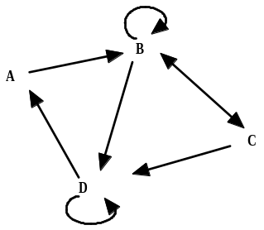
How many simple paths of length 2 exist in the following directed graph?

