American Computer Science League
2003-2004

Contest #3

Junior Division Solutions

1. What Does This Program Do – Subscripts
1. -5

J | K | A(J,K) | X
1 | 1 | 8 | 8
1 | 2 | 1 | 7
1 | 3 | 6 | 13
2 | 1 | 3 | 10
2 | 2 | 5 | 5
2 | 3 | 7 | -2
3 | 1 | 4 | 2
3 | 2 | 9 | -7
3 | 3 | 2 | -5

2. Digital Electronics
2. (1,1)
The circuit translates to 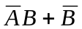
 |  | 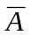 | 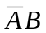 | 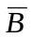
0 | 0 | 1 | 0 | 1 | 1
0 | 1 | 1 | 1 | 0 | 1
1 | 0 | 0 | 0 | 1 | 1
1 | 1 | 0 | 0 | 0 | 0

3. 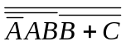

3. Digital Electronics
The circuit translates to: . Parentheses are not required and
should not be part of the answer. AND operation symbols (∗ or •) may
be included.

4. Graph Theory
4. 2

 | A | B | C | D
A | 0 | 1 | 0 | 0 | 2 |  | 0 | 0 | 1 | 1
B | 0 | 0 | 1 | 1 |  | = | 1 | 1 | 1 | 0
C | 1 | 1 | 0 | 0 |  |  | 0 | 1 | 1 | 1
D | 0 | 0 | 1 | 0 |  |  | 1 | 1 | 0 | 0

The number of paths from A is found by summing the top row of the squared
matrix.

5. Graph Theory
5. 7
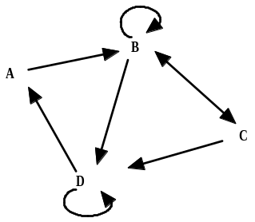
The simple paths are:
1. ABC
2. ABD
3. BCD
4. CBD
5. BDA
6. DAB
7. CDA

