American Computer Science League
2003-2004

Contest #4

Junior Division Solutions

1. What Does This Program Do – Subscripts
1. M

The original A$ has its letters compared from each end, letter 1 is compared with letter
21, 2 is compared with 20, etc. If the first numbered letter is the bigger, it is added to
X$. The second loop adds just those letters less than N to Y$.
X$=”UNTSTTOM” and Y$ = “M”.

2. Prefix/Infix/Postfix
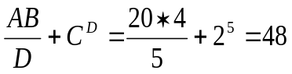
2. 48

+ / * A B D ↑ C D becomes

3. S A A R N ↑ * - 1 R - / =
3. Prefix/Infix/Postfix

S = (A –A*R^{N}) / (1 – R) in infix converts to

S A A R N ↑ * - 1 R - / = in postfix.

4. Data Structures
4. 5

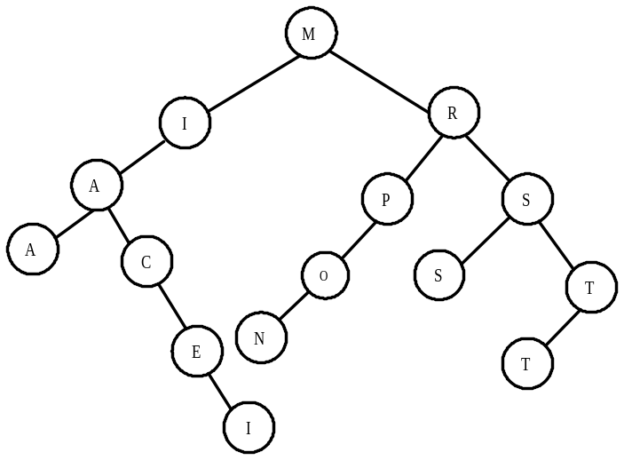

5. C
5. Data Structures

The queue just before each POP:

DAT D is POPPED
ATA A is POPPED
TAST T and A are POPPED
STRUC S, T and R are POPPED
UCTUR U is POPPED
CTURE C would be the next letter POPPED

