American Computer Science League
2004-2005

All-Star

TEST QUESTIONS

- Digital Electronics
1
A. (1,1,1)
B. (0,1,*)
C. (*,0,0)
D. (*,*,0)
E. None of the above
List all the ordered triples that make the circuit TRUE.
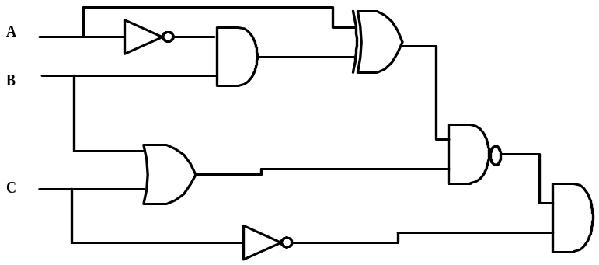

2.
A. 2
B. 3
C. 6
D. 7
E. None of the above

2. Recursive Functions
Find f (6,4)

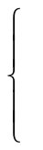
f ( x − y , x – 2 ) + 2 if x >y
f (y – x, y – 1 ) −1 if x < y
3x + 2y if x = y
f (x,y) =

3.
A. 101₂
B. 111₂
C. 1010₂
D. 11₂
E. None of the above
3. Computer Number Systems

Solve for X₂:

1.2₈ X₂ - .8 ₁₆ X₂ = 111.1₂ - .11₂ X₂

4. Data Structures
4.
A. 12
B. 18
C. 20
D. 24
E. None of the above

Construct a binary search tree with the letters LANCASTER. Now
add the letters AMISH. By how much does the internal path
length increase?

American Computer Science League
2004-2005

All-Star

TEST QUESTIONS

5. Graph Theory 5.
Given the adjacency matrix which contains the
A. 110
010
100

B. 100
101
001

C. 111
011
100

D. 101
011
100
E. None of the above
number of paths of length 2 in a directed graph, which of the following
is the original adjacency matrix.

 | A | B | C
A | 2 | 0 | 1
B | 1 | 1 | 1
C | 1 | 0 | 1

6. Bit String Flicking
6.
A. LCIRC - 2
B. RCIRC - 2
C. RSHIFT - 1
D. LSHIFT - 1
E . None of the above

When substituted for OPERATOR-N which of the following
will make the statement true?

(RCIRC – 2 (LSHIFT –1 (OPERATOR –N 00010 ) ) ) =
(RSHIFT- 1 01110) AND (LCIRC – 2 10110)

7.
A. 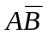
B. 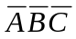
C. 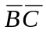
D. 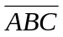
E. None of the above

7. Boolean Algebra

Simplify completely so that only NOT operators and one other
type of operator is used.

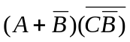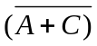

American Computer Science League
2004-2005

All-Star

TEST QUESTIONS

8. FSA’s and Regular Expressions
8.
A. a(ba*aba∪aba)∪(aba*b)
B. a(ba*a(ba∪ab)a)∪aba*ab
C. a[(ba*a(ba∪ab)a)∪(aba*ab)]
D. a[(ba*aba∪aba)∪aba*ab]
E. None of the above

Which Regular Expressions represent this FSA.

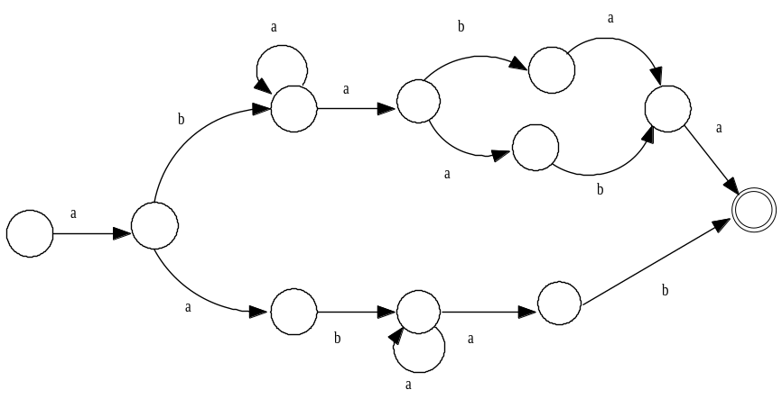

9. LISP
9.
A. (8)
B ‘(8)
C. (‘8)
D. 8
E. None of the above

Evaluate the following:
(CAR(REVERSE(CAR(CDR(REVERSE(CDR’((1 2) 3 (4 5) (6 7 8) 9 )))))))

10. Prefix/Infix/Postfix
10.
A. 1
B. 2
C. 1.5
D. 2.25
E. None of the above

Define A @ B = A^{B} and ! A = 1/A. Evaluate the following postfix
expression. Note that all the terms are single digits.

3 2 3 @ 7 + 3 2 @ - ! * 2 ! /

American Computer Science League
2004-2005

All-Star

TEST QUESTIONS

11. Assembly Language Programming
11.
A. 8
B. 10
C. 12
D. 16
E. None of the above

If the following program prints 144, What is the
initial value of K?

READ K
S DC 0
J DC 1
LOAD S
ADD K
STORE S
TEST LOAD K
SUB J
BE DONE
LOAD J
ADD =1
STORE J
LOAD S
ADD K
STORE S
BU TEST
DONE PRINT S

12.
A. 10
B. 14
C. 19
D. 21
E. None of the above
12. What Does This Program Do?
4 | 1 | 3 | 4
2 | 2 | 2 | 4
1 | 3 | 5 | 3
Given the following array A as stored in memory, what is the final value of S after the following program is executed? Note that A(1,1) = 4 and A(1,2) =1

S = 0
FOR I = 1 TO 3
FOR J = 1 TO 4
IF A(I,J)/2 = INT(A(I,J)/2)
THEN A(I,J) = A(I,J)/2
ELSE A(I,J) = I*J
NEXT J
NEXT I
FOR J=1 to 4
IF A(1,J)>2
THEN A(1,J) = A(1,J) – 2
IF A(2,J) <5
THEN A(2,J) = A(2,J) + 5
IF A(3,J) >J
THEN A(3,J) = A(3,J) – J
NEXT J
FOR I= 1 TO 3
S = S + A(I,I)
NEXT I
END

