American Computer Science League
2004-2005

All-Star

TEST SOLUTIONS

1. C
1. Digital Electronics

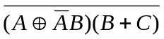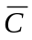 = 1 ⇒ =0 and = 1
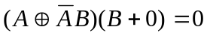
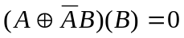
If B=0 then A = *
If B = 1 then 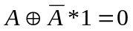. This implies 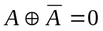.
But that is impossible. So the triplets are (*, 0 ,0).

2. Recursive Functions
2. E
f(6,4) = f(2,4) + 2 2 + 2 = 4
f(2,4) = f(2,3) – 1 3 – 1 = 2
f(2,3) = f(1,2) - 1 4 - 1= 3
f(1,2) = f(1,1) – 1 5 – 1 = 4
f(1,1) = 3*1 + 2*1 = 5

3. A
3. Computer Number Systems

1.2₈ X₂ - .8₁₆ X₂ = 111.1₂ - .11₂ X₂
1.25 X₂ - .5 X₂ = 7.5 - .75 X₂
1.5 X₂ = 7.5
X₂ = 5₁₀
X₂ = 101₂

4. Data Structures
4. B
The internal path length of the original tree is 17. The A adds 3, the M adds 2, the I adds 4, the S adds 4 and the H adds 5 for a total of 18.
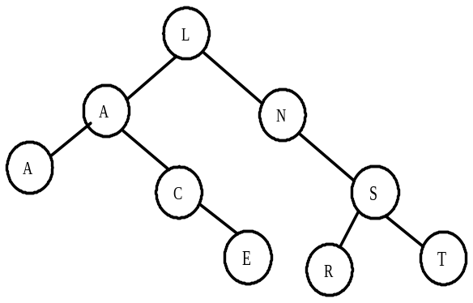

American Computer Science League
2004-2005

All-Star

TEST SOLUTIONS
5. D
5. Graph Theory

1 | 0 | 1 | 2 |  | 2 | 0 | 1
0 | 1 | 1 |  | = | 1 | 1 | 1
1 | 0 | 0 |  |  | 1 | 0 | 1

6. Bit String Flicking
6. D
(RSHIFT- 1 01110) AND (LCIRC – 2 10110) = 00010
(RCIRC – 2 (LSHIFT –1 (LSHIFT – 1 00010) = 00010

7. Boolean Algebra
7. B

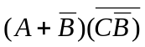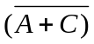 = 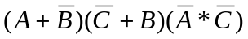=
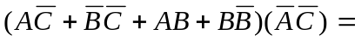

8. C
8. FSA’s and Regular Expressions

The regular expression is: a[(ba*a(ba∪ab)a)∪(aba*ab)]

8. A
9. LISP
9. D

(CAR(REV(CAR(CDR(REV(CDR’((1 2) 3 (4 5) (6 7 8) 9 ))))))) =
(CAR(REV(CAR(CDR(REV’( 3 (4 5) (6 7 8) 9 )))))) =
(CAR(REV(CAR(CDR’( 9 (6 7 8) (4 5) 3 ))))) =
(CAR(REV(CAR’( (6 7 8) (4 5) 3 )))) =
(CAR(REV’( (6 7 8))) =
(CAR’(8 7 6)) = 8

American Computer Science League
2004-2005

All-Star

TEST SOLUTIONS

10. Prefix/Infix/Postfix
10. A

3 2 3 @ 7 + 3 2 @ - ! * 2 ! / = 3 (2³) 7 + (3²) - ! * 2 ! / =
3 8 7 + 9 - ! * 2 ! / = 3 15 9 - ! * 2 ! / =
3 6 ! * 2 ! /= 3 (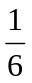) * (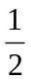 ) / = 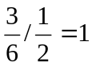

11. Assembly Language Programming

All-Star
11. C

The program translates to the following algorithm:

INPUT K
S is incremented by K, K times. So K² = 144 and K = 12
S = 0
FOR J = 1 to K
S = S + K
NEXT J
PRINT S

12. What Does This Program Do?
The array changes as follows after each set of FOR loops:
12. B

4 | 1 | 3 | 4
2 | 2 | 2 | 4
1 | 3 | 5 | 3
2 | 2 | 3 | 2
1 | 1 | 1 | 2
3 | 6 | 9 | 12

2 | 2 | 1 | 2
6 | 6 | 6 | 7
2 | 4 | 6 | 8
2 | 2 | 1 | 2
6 | 6 | 6 | 7
2 | 4 | 6 | 8

The program then causes A(1,1), A(2,2) and A(3,3) to be added.
The total is 14.

