American Computer Science League
2004-2005

Contest #2

Intermediate Division Short Problems

1. Computer Number Systems
Multiply and express the answer in octal:

FF_{16 *} 10001₂

2. Boolean Algebra
Simplify :

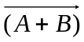 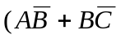)

- Boolean Algebra
How many ordered triples make the following expression FALSE?

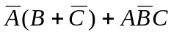

4. Bit String Flicking
Evaluate:

(RCIRC-3 (LSHIFT-1 (LCIRC-2 (RSHIFT-1 10110 ) ) ) )

5. Bit String Flicking
Solve for X (a 5-bit string):

(LCIRC-2 01110) AND X = (RSHIFT-1 10011)

