American Computer Science League
2004-2005

Contest #2

Intermediate Division Solutions

1. 10357₈
1. Computer Number Systems
FF_{16 *} 10001₂ = 11111111₂
x 10001₂

11111111
111111110000
1 000 011 101 111₂ = 10357₈

2. Boolean Algebra
2. 0
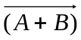 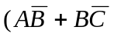) = 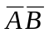) =
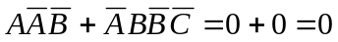

- Boolean Algebra
3. 4
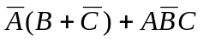
A | B | C | 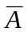 | 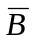 | 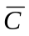 | 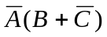 | 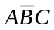
0 | 0 | 0 | 1 | 1 | 1 | 1 | 0 | 1
0 | 0 | 1 | 1 | 1 | 0 | 0 | 0 | 0
0 | 1 | 0 | 1 | 0 | 1 | 1 | 0 | 1
0 | 1 | 1 | 1 | 0 | 0 | 1 | 0 | 1
1 | 0 | 0 | 0 | 1 | 1 | 0 | 0 | 0
1 | 0 | 1 | 0 | 1 | 0 | 0 | 1 | 1
1 | 1 | 0 | 0 | 0 | 1 | 0 | 0 | 0
1 | 1 | 1 | 0 | 0 | 0 | 0 | 0 | 0

4. Bit String Flicking
4. 01011
(RCIRC-3 (LSHIFT-1 (LCIRC-2 (RSHIFT-1 10110 ) ) ) ) =
(RCIRC-3 (LSHIFT-1 (LCIRC-2 01011) ) )
(RCIRC-3 (LSHIFT-1 01101) )
(RCIRC-3 11010) = 01011

5. Bit String Flicking
5. 01**1
(LCIRC-2 01110) AND X = (RSHIFT-1 10011)
Let X = abcde
11001 AND abcde = 01001 implies
a = 0, b = 1, c = *, d = *, e = 1

