ACSL
American Computer Science League
2006 - 2007

Contest #1

Intermediate Division

1. Recursive Functions
Find 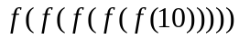

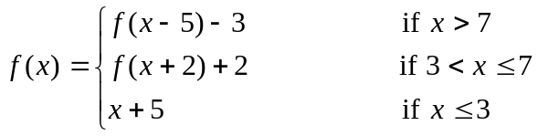
- Recursive Functions
Find 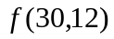where max is the bigger result of the 2 arguments.

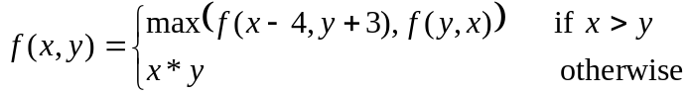

3. Computer Number Systems
Convert from hexadecimal to octal: A2B8C4D6₁₆
4. Computer Number Systems
A palindrome is a number like 1221 that reads the same from left to right as it does from right to left. Convert the numbers from 10₁₀ to 100₁₀ to octal. How many octal palindromes exist in that interval?

- LISP
Evaluate:

(DIV (MULT (ADD 1 4 5 ) (SUB 7 2 )) (EXP 5 2 ))

