ACSL
American Computer Science League
2006 - 2007

Contest #2

Intermediate Division

1. Boolean Algebra
Simplify completely:

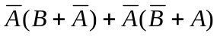

- Boolean Algebra
List all the ordered triples that make the following expression TRUE:
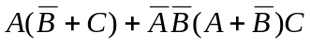

3. Computer Number Systems
What is the positive difference between the number of 1’s in the binary representation of the following two values:

A37E₁₆ and 67541₈
4. Bit-String Flicking
Evaluate:

((RSHIFT-2 (10110 AND 10010)) OR (LCIRC-3 (01101 OR 10001)))

- Bit-String Flicking
List all the values of X ( a 5-bit string) that make the following expression TRUE:

(LSHIFT-2 (RCIRC-1 ( NOT X ))) = 10000

