ACSL
American Computer Science League
2006 - 2007

Contest #1

Junior Division

1. Recursive Functions
Find (23)
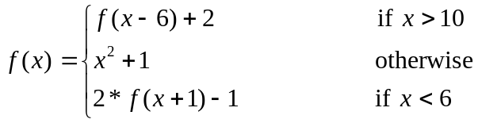
- Recursive Functions
Find (5, 11)
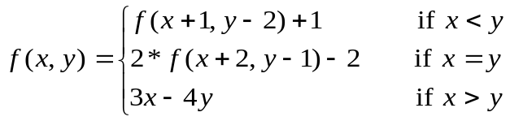

3. Computer Number Systems
Solve for X₁₆
100101₂ + X₁₆ = 1101101010₂
4. Computer Number Systems
Arrange the numbers in order from smallest to largest. Write their letters in that order.
A) 52₁₆ B) 124₈ C) 83₁₀ D) 1010001₂

- What Does This Program Do?
After the following program is run, what are the values of the four program variables?

A=1: B=2: C=5: D=12
IF (A+C) >(D/B) THEN C=C+B ELSE A=2*D
IF (D−B) ≤ (4*A) THEN B=B+4 ELSE D=D/2
IF (A*C) > (B*D) THEN A=A*C ELSE D=B*D
IF (A>B) OR (C<D) THEN A=B-1 ELSE C=D−2

A=

B=

C=

D=

