ACSL
American Computer Science League
2006 - 2007

Contest #2

Junior Division Solutions

1. Boolean Algebra
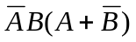= 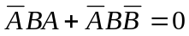

1. 0
- Boolean Algebra
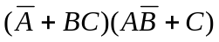= 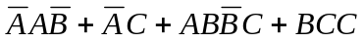=
If .
The triplets are (*,1,1) and (0,0,1)
4. Bit-String Flicking
(NOT (LSHIFT-2 (RCIRC-1 01101 )))
(RCIRC-1 01101) = 10110
(LSHIFT-2 10110) = 11000
(NOT 11000) = 00111
3. Bit-String Flicking
(00101 OR 01011 AND 10110 XOR 01110 OR 11011 AND 10110) =
The order of operations is AND, XOR and then OR.
(00101 OR ((01011 AND 10110) XOR 01110) OR (11011 AND 10110))=
11111
- What Does This Program Do?
The J loop produces values 15, 18, 21, 24,…48. The I loop produces the odd numbers from 1 to 25. The IF statement asks which values of I divide the J values with no remainder.

I | # of * | I | # of *
1 | 12 | 15 | 3
3 | 12 | 17 | 0
5 | 3 | 19 | 0
7 | 2 | 21 | 2
9 | 4 | 23 | 0
11 | 1 | 25 | 0
13 | 1 | TOTAL | 40

2. 3
3. 11111
4. 00111
5. 40

