ACSL
American Computer Science League
2006 - 2007

Contest #3

Junior Division

1. Graph Theory

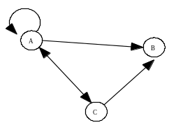

How many paths of length 2 exist in this directed graph?

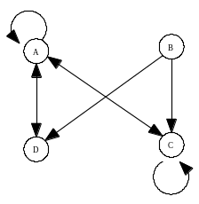
- Graph Theory

Write the adjacency matrix for the directed graph.

3. Digital Electronics
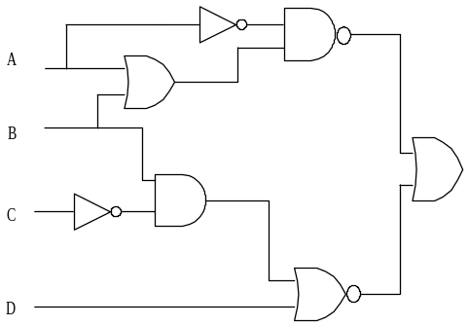

Translate (do not simplify) into a Boolean expression using the fewest parentheses possible.

- Graph Theory
How many ordered triples make the circuit TRUE?
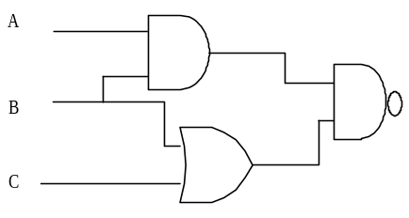

- What Does This Program Do?

FOR I = 1 to 4
FOR J = 1 to 4
IF A(I,J)/2 = INT (A(I,J)/2) THEN A(I,J) = A(I,J)/2
ELSE A(I,J) = A(I,J) + 1
IF A(I,J) < 0 THEN A(I,J) = ABS(A(I,J))
ELSE A(I,J) = −1 * A(I,J)
NEXT J
NEXT I
PRINT A(2,2) * A(3,3)
END
Given array A below with A(1,1) = −1, what is printed when the following program is run?

3 | 2 | 4 | 5 | 1
0 | 1 | 3 | 2 | 6
1 | 2 | 1 | 3 | 4

−1 | 2 | 1 | 0
−2 | 1 | 0 | 3
4 | −3 | 1 | 2
1 | 3 | −2 | 6

