ACSL
American Computer Science League
2006 - 2007

Contest #3

Junior Division Solutions

- Graph Theory
1 | 1 | 1 | 2 |  | 2 | 2 | 1
0 | 0 | 0 |  | = | 0 | 0 | 0
1 | 1 | 0 |  |  | 1 | 1 | 1

1. 8

- Graph Theory

1 | 0 | 1 | 1
0 | 0 | 1 | 1
1 | 0 | 1 | 0
1 | 0 | 0 | 0

2. As shown

3. Digital Electronics
3. 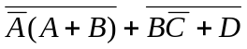

The circuit translates as follows:

- Graph Theory
The circuit translates to 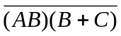 = 1 ⇒ 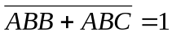⇒
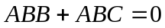 ⇒ 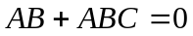⇒ 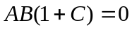⇒ 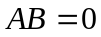
If A = 0 then B = * and C = *
If B = 0 then A = * and C= *
- 6

(0, *,* ) and (*, 0, *) Therefore 6 ordered triples.

- What Does This Program Do?

5. 4

The program produces the following array:

3 | 2 | 4 | 5 | 1
0 | 1 | 3 | 2 | 6
1 | 2 | 1 | 3 | 4

0 | -1 | -2 | 0
1 | -2 | 0 | -4
-2 | 2 | -2 | -1
-2 | -4 | 1 | -3

