ACSL
American Computer Science League
2007 - 2008

All-Star

Short Round Solutions
- Boolean Algebra
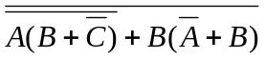 = 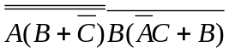 = 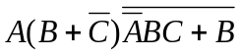
=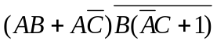 = 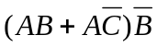
= 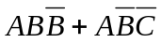 = 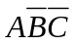

1. (D) 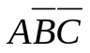

2. Digital Electronics
A | B | C | D |  | C+D | ~C | ◊ | A | +◊ | XOR
0 | 0 | 0 | 0 | 0 | 0 | 1 | 1 | 0 | 1 | 1
0 | 0 | 0 | 1 | 0 | 1 | 1 | 0 | 0 | 0 | 0
0 | 0 | 1 | 0 | 1 | 1 | 0 | 1 | 0 | 1 | 1
0 | 0 | 1 | 1 | 1 | 1 | 0 | 1 | 0 | 1 | 1
0 | 1 | 0 | 0 | 1 | 0 | 1 | 1 | 0 | 1 | 1
0 | 1 | 0 | 1 | 1 | 1 | 1 | 0 | 0 | 1 | 1
0 | 1 | 1 | 0 | 0 | 1 | 0 | 1 | 0 | 1 | 1
0 | 1 | 1 | 1 | 0 | 1 | 0 | 1 | 0 | 1 | 1
1 | 0 | 0 | 0 | 1 | 0 | 1 | 1 | 1 | 1 | 0
1 | 0 | 0 | 1 | 1 | 1 | 1 | 0 | 1 | 1 | 0
1 | 0 | 1 | 0 | 0 | 1 | 0 | 1 | 0 | 1 | 1
1 | 0 | 1 | 1 | 0 | 1 | 0 | 1 | 0 | 1 | 1
1 | 1 | 0 | 0 | 0 | 0 | 1 | 1 | 0 | 1 | 1
1 | 1 | 0 | 1 | 0 | 1 | 1 | 0 | 0 | 0 | 0
1 | 1 | 1 | 0 | 0 | 1 | 0 | 1 | 0 | 1 | 1
1 | 1 | 1 | 1 | 0 | 1 | 0 | 1 | 0 | 1 | 1

2. (B) 12

3. Prefix-Infix-Postfix
1 2 # 3 % 4 5 % # 5 % 6 # 7 8 # # = (1 2 #)3 % (4 5 %) # 5 % 6 # (7 8 #) #
= (1 3 %) 9 # 5 % 6 # 1 #
= ( 4 9 # )5 % 6 # 1 #
= ( 5 5 %) 6 # 1 #
= (10 6 # ) 1 # = -4 1 # = 5

3. (B) 5

4. Computer Number Systems
A B C Note C = A + 1 and possible values of A are 1,2,3,4,5,6.
+ A B
C 2 2 A = 1 102 A = 2 273 A = 3 364
+ 10 + 27 + 36
112 ≠C22 322 422

A = 4 455 A = 5 546 A = 6 637
+ 45 + 54 + 63
522 A ≠ B 622 722
4. (D) 4

- Bit String Flicking Let X = abcde and NOT X = ABCDE
LHS = (RCIRC-3 (LSHIFT-2 abcde)) OR (11110 AND 11001)
= (RCIRC-3 cde00) OR 11000
= e00cd OR 11000 = 110cd
RHS = (RCIRC-3 (NOT abcde)) OR (11010 OR 10001)
= (RCIRC-3 ABCDE) OR 11011
= CDEAB OR 11011 = 11E11
110cd = 11E11 ⇒ E = 0, c = 1, d = 1
⇒ e = 1, c = 1, d = 1, a = *, b= * ∴ **111

5. (C) 4

6. What Does This Program Do?

2 | 3 | 4 | 5
2 | 4 | 5 | 6
3 | 9 | 6 | 7
4 | 16 | 64 | 8
5 | 25 | 125 | 625

6. (C) 177

Second loop adds the entries that are not perfect squares. Therefore, S = 177

7. (B) -49

- Recursive Functions
f(11, -4) = f( [11/2]-2, 2 *⎜-4 - 1⎜) + (11*-4)
= f(3, 10) – 44 = -5 – 44 = -49
f(3,10) = f(⎜⎜10⎜ - 3⎢, [3/10] – 2) – 10
= f(7, -2) -10 = 5 – 10 = -5
f(7, -2) = f(⎜⎜-2⎜ - 7⎜, [7/(-2)] – 2) – (-2)
= f(5, -6) + 2 = 3 + 2 = 5
f(5, -6) = f(⎜⎜-6⎜ - 5⎜, [5/(-6)] – 2) – (-6)
= f(1, -3) + 6 = -3 + 6 = 3
f(1, -3) = gcf(1, -3) * [-3/1]
= 1 * (-3) = -3 Now substitute backwards.

- Graph Theory
The original 5 cycles from A are :
AB, ABE, ABCE, ABCED and ABED
The 7 new cycles when AE and BD are added are:
AE, AEB, AEBD, AED, ABD, ABDE, and ABDCE

8. (E) None of the above

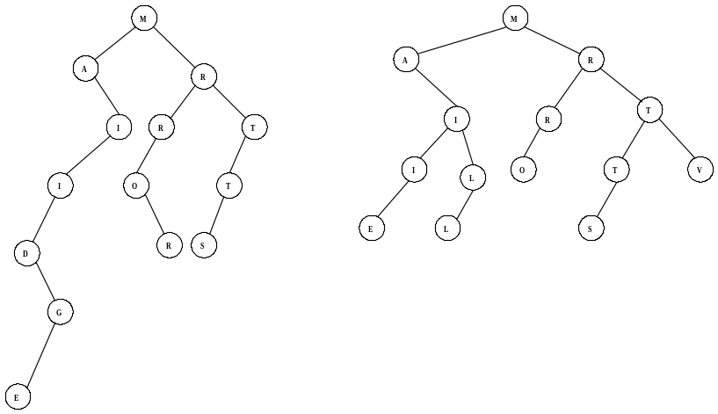
- Data Structures
MARRIOTTSRIDGE MARRIOTTSVILLE

9. (B) 5

Internal length = 40 internal length = 35
- LISP
(REVERSE(CDR ‘ ( (1 2) 3 4)))
= (REVERSE ‘ ( 3 4))
= (4 3)

10. (A) (4 3)

- FSA and Regular Expressions
The string must start with ab.
Travelling along the left branch of the union yields:
abbcbcbcaa which has a length of 10
The right branch yields: abcbbbaa which has a length of 8.

11. (D) 10

- Assembly Language
The high level program equivalent to the program is as follows:
S = 0
A = 5
B = 40
FOR I = 1 TO B STEP A
S = S + I * A
NEXT I
PRINT S
END
I takes on values of: 1, 6, 11, 16, 21, 26, 31, 36
I*A has values of: 5, 30, 55, 80, 105, 130, 155, 180
The sum is 740.
12. (C) 740

