ACSL
American Computer Science League
2007 - 2008

Contest #1

Intermediate Division

1. Recursive Functions
Find (32), given:

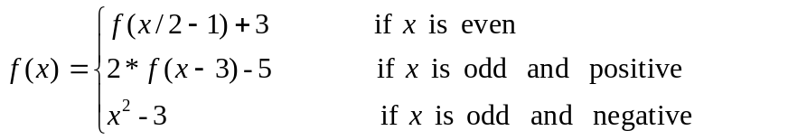
- Recursive Functions

If (1) = 8 and (n+1) = 2*(n) – 4, find (5).
3. Computer Number Systems
Which of the following octal numbers has the most 1’s in its
binary representation?

A) 155555₈ B) 133337₈ C) 145547₈ D) 156464₈ E) 171442₈
4. Computer Number Systems
Evaluate and express the answer in binary:

243₈ + 91₁₆ – 82₁₆ / 1101₂

- LISP
Evaluate the following expression:

(ADD (ADD 3 4)(SUB 5 2)(MULT 3 2)(EXP 2 3))

