ACSL
American Computer Science League
2007 - 2008

Contest #2

Intermediate Division

1. Boolean Algebra

Simplify completely:

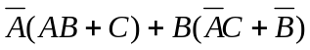

- Boolean Algebra

What ordered triples make the following expression TRUE?

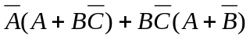

3. Computer Number Systems

Solve for X₁₆:

1F₁₆ * X₁₆ + 476₈ = 1010110010₂

4. Bit-String Flicking

Evaluate the following expression:

(NOT 10111 OR LCIRC-2 01110 OR LCIRC-1 00110 AND RSHIFT-2 10110)

- Bit-String Flicking

List all possible values of X (5 bits long) that solve the following equation:

(LSHIFT-2 01011 AND RCIRC-2 X) = 00100

