ACSL
American Computer Science League
2007 - 2008

Contest #2

Intermediate Division Solutions

1. Boolean Algebra
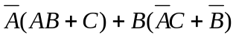 = 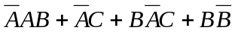
= 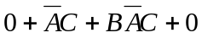
= 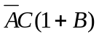
= 

1.

3. Computer Number Systems
1F₁₆ * X₁₆ + 476₈ = 1010110010₂
Converting to base 10, the equation becomes:
31 * X + 318 = 690
31 * X = 372
X = 12 Convert 12 to hex which is C.

4. Bit-String Flicking
The order of precedence is NOT, AND and then OR.
(NOT 10111 OR LCIRC-2 01110 OR LCIRC-1 00110 AND RSHIFT-2 10110)
= (01000 OR 11001 OR 01100 AND 00101)
= (01000 OR 11001 OR 00100) = (11001 OR 00100) = 11101
- Bit-String Flicking
Let X = abcde
(LSHIFT-2 01011) = 01100
(RCIRC-2 abcde) = deabc
(01100 AND deabc) = 00100 ⇒ a = 1, b = *, c = *, d = *, e = 0

Boolean Algebra
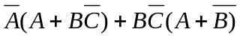 = 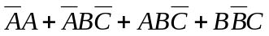
= 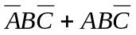
= 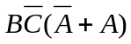
= 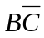
If = 1, then  = 1 and  = 0. Also  = *.
2. (*,1,0)

or

(0,1,0) and
(1,1,0)
3. C₁₆ or C
4. 11101
5. 1***0

