ACSL
American Computer Science League
2007 - 2008

Contest #3

Intermediate Division

1.
- Boolean Algebra
How many ordered triples make the following expression TRUE?

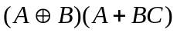

2.
- Graph Theory
Given the adjacency matrix,
draw the directed graph.
 | A | B | C | D
A | 1 | 0 | 1 | 1
B | 0 | 1 | 1 | 0
C | 1 | 0 | 1 | 0
D | 1 | 1 | 1 | 1

3.
- Graph Theory
How many paths of length 2
exist from vertex B in this
directed graph?

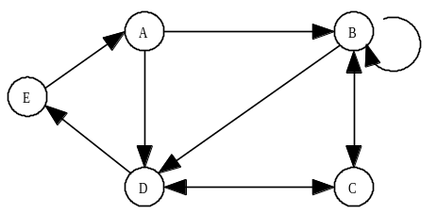

4.
- Digital Electronics

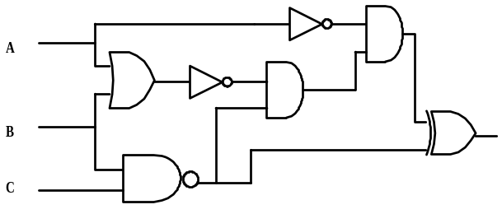

Which ordered triples make this circuit FALSE?

- Digital Electronics

5.
Simplify the Boolean expression that this circuit represents.
