ACSL
American Computer Science League
2007 - 2008

Contest #3

Intermediate Division Solutions

- Boolean Algebra
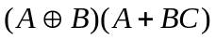
 |  |  | 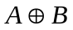 |  |  | 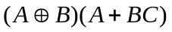
0 | 0 | 0 | 0 | 0 | 0 | 0
0 | 0 | 1 | 0 | 0 | 0 | 0
0 | 1 | 0 | 1 | 0 | 0 | 0
0 | 1 | 1 | 1 | 1 | 1 | 1
1 | 0 | 0 | 1 | 0 | 1 | 1
1 | 0 | 1 | 1 | 0 | 1 | 1
1 | 1 | 0 | 0 | 0 | 1 | 0
1 | 1 | 1 | 0 | 1 | 1 | 0

1. 3

- Graph Theory

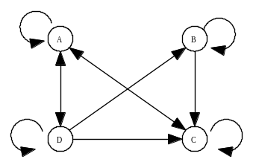

2. As shown

3. 7
- Graph Theory
0 | 1 | 0 | 1 | 0 | 2 |  | 0 | 1 | 2 | 1 | 1
0 | 1 | 1 | 1 | 0 |  |  | 0 | 2 | 2 | 2 | 1
0 | 1 | 0 | 1 | 0 |  | = | 0 | 1 | 2 | 1 | 1
0 | 0 | 1 | 0 | 1 |  |  | 1 | 1 | 0 | 1 | 0
1 | 0 | 0 | 0 | 0 |  |  | 0 | 1 | 0 | 1 | 0

Squaring an adjacency matrix produces all the paths of length 2.

4. (0,0,0)
(0,0,1)
(1,1,1)
(0,1,1)
- Digital Electronics
The circuit translates to 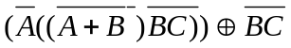
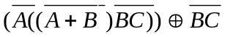= 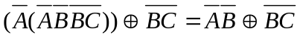
To be FALSE, both sides of  must the same. If both T, then (0,0,*)
If both F, then (*,1,1)

- Digital Electronics
This circuit translates to 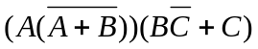
= 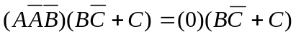
= 0
5. 0

