ACSL
American Computer Science League
2007 - 2008

Contest #4

Intermediate Division

1.
- Data Structures
In the binary search tree for EDGARALLENPOE, list all nodes that have 2 children?

2.
- Data Structures
What would be the next item popped from the queue constructed by
the following commands?

PUSH(T), PUSH(H), PUSH(E), POP(X), PUSH(R), PUSH(A),
POP(X), POP(X), PUSH(V), PUSH(E), POP(X), PUSH(N),
POP(X), POP(X)

- Prefix-Infix-Postfix
Convert the following postfix expression to prefix:

A B * C A / + A B ↑ - B C / +

3.

4.
- Prefix-Infix-Postfix
Evaluate the following prefix expression. Note the numbers are single digits in the expression.

+ - + 3 / 4 2 / 8 + 3 1 * 6 2

5.
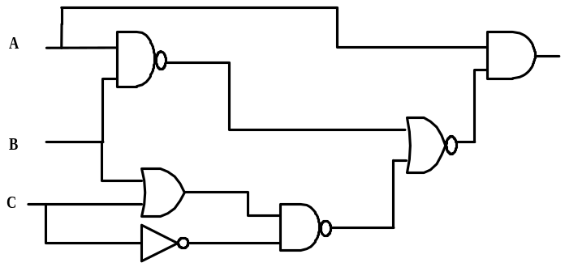
- Digital Electronics

List all the triples that make the digital circuit TRUE.

