ACSL
American Computer Science League
2006 - 2007

Contest #4

Intermediate Division Solutions

1. E, D, L
(in any order)

- Data Structures
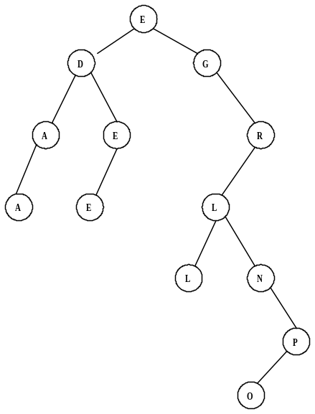
The only nodes with two children are E, D, and L.

2. E
- Data Structures
The queue is constructed as follows:
THE, HE, HERA, RA, RAVE, AVE, AVEN, EN
The next popped item is E since queues are FIFO.

3. As shown
- Prefix-Infix-Postfix
A B * C A /+ A B ↑ - B C / + converts to the following prefix expression:

+ - + * A B / C A ↑ A B / B C

4. 15
- Prefix-Infix-Postfix
+ - + 3 / 4 2 / 8 + 3 1 * 6 2 = + - + 3 (4 / 2) / 8 (3 + 1) (6*2)
= + - (3 + 2) (8 / 4) 12
= + (5 – 2) 12 = 3 + 12 = 15

- Digital Electronics
The digital diagram translates as follows:
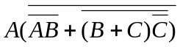 = 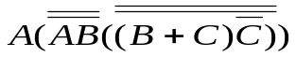
= 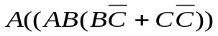
= 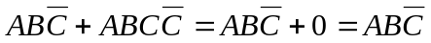 = 1
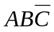 = 1 ⇒  = 1,  = 1, and  = 0 ∴ (1, 1, 0)

5. (1, 1, 0)

