ACSL
American Computer Science League
2012 - 2013

All-Star

Short Round Solutions
- Boolean Algebra
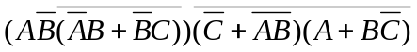 = 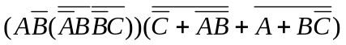
=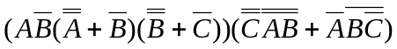=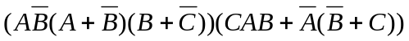
==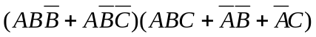
=

1. (D) 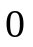

2. Digital Electronics
The digital circuit is represented by the following Boolean
expression: 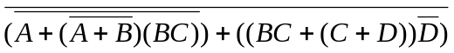
= 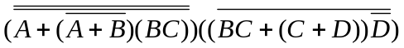
= 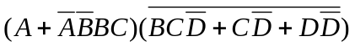= 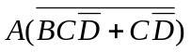
= 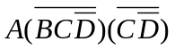= 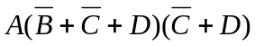
=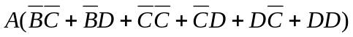=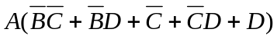
= 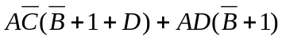=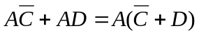
If 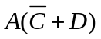 = 1, then 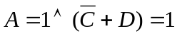.
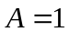for half the ordered quadruples or 8.
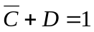for 6 of those 8 ordered quadruples.
Therefore 6 ordered quadruples make the circuit TRUE.

2. (B) 6

3. Prefix-Infix-Postfix
5 8 % 2 3 8 4 # # + * 4 6 8 # # 2 3 ↑ / * 6 ! 3 8 % / +
= (5 8 %) 2 3 (8 4 #) # + * 4 (6 8 #) # (2 3 ↑) / * (6 ! )(3 8 % ) / +
= 40 2 (3 4 #) + * (4 2 #) 8 / * (720 24 /) +
= 40 (2 1 +) * (2 8 /) * 30 +
= (40 3 *) .25 * 30 + = (120 .25 * ) 30 + = 30 30 + = 60

= ( 5 5 %) 6 # 1 #
= (10 6 # ) 1 # = -4 1 # = 5

3. (E) None of the above

4. Computer Number Systems
X614₈ = 512*X + 6*64 + 1 * 8 + 4 = 512*X + 396
X50₁₆ = 256*X + 5*16 + 0 = 256*X + 80
X614₈ + X50₁₆ = 768*X + 476 = 2012
768*X = 1536
X = 2

4. (C) 2

- Bit String Flicking Let X = abcde
LHS = NOT(LCIRC-2 11101) OR RSHIFT-1 01011 AND
RCIRC-1(LSHIFT-2 01101)
= NOT 10111 OR 00101 AND RCIRC-1 10100
= 01000 OR 00101 AND 01010 = 01000 OR 00000 = 01000
RHS = LSHIFT-2 (RCIRC-2 X) = LSHIFT-2 (RCIRC-2 abcde)
= LSHIFT-2 deabc = abc00
So 01000 = abc00 ⇒ a = 0, b = 1, c = 0, d = *, e = * ∴ 010**
5. (C) 010**

6. What Does This Program Do?
a: 3 4 5 6 7 b: 3 7 11 15 19 c: 4 9 14 19 24
5 6 7 8 9 6 10 14 18 0 10 16 22 26
7 8 9 10 11 9 13 17 0 0 18 25 32
9 10 11 12 13 12 16 0 0 0 28 36
11 12 13 14 15 15 0 0 0 0 40
a(2,4)+b(1,3)+c(4,5) = 8 + 11 + 40 = 55

6. (B) 55

7. (C) 9

- Recursive Functions
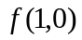 = 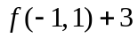 = 1 + 3 = 4
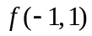 = -1 + 2*1 = -1 + 2 = 1
So 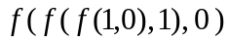 = 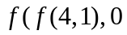)
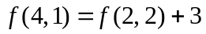= 3 + 3 = 6
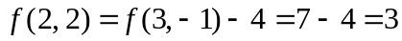
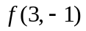= 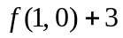= 4 + 3 = 7
So = 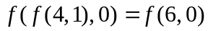
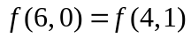+ 3 = 6 + 3 + 9
So = = 9

- Data Structures
M, ME, MEM, EM, EMO, OME, ME, MER, MERI, ERI, EIR,
IR, IRA, IRAL, RAL, RALD, ADLR, ADLRA, DLRA, RLDA,
RLDAY, LDAY
POP(X) would remove the L.

8. (A) L

- Graph Theory
The cycles from B are BB, BAB, BCB, BADECB, BCDEAB, BCEAB, BDEAB, BDECB, BDAB, BEAB, BCDAB, BECB, and BECDAB

9. (B) 13

- LISP
(CDR(CAR(REVERSE(CDR(CAR(REVERSE(CDR X) ) ) ) ) ) )
= (CDR(CAR(REVERSE(CDR(CAR(REVERSE(CDR ’( (1 2 ) 3
( ( 4 5 ) 6 ) 7 ( 6 ( 5 4 ) ( 3 2 ( 1 ) ) ) ) ) ) ) ) ) ) )
= (CDR(CAR(REVERSE(CDR(CAR(REVERSE ’( 3 ( ( 4 5 ) 6 ) 7
( 6 ( 5 4 ) ( 3 2 ( 1 ) ) ) ) ) ) ) ) ) )
= (CDR(CAR(REVERSE(CDR(CAR ’( ( 6 ( 5 4 )( 3 2 ( 1 ) ) )
7 ( ( 4 5 ) 6 ) 3 ) )))))
= (CDR(CAR(REVERSE(CDR ’ ( 6 ( 5 4 )( 3 2 ( 1 ) ) ) ))))
= (CDR(CAR(REVERSE ’ ( ( 5 4 )( 3 2 ( 1 ) ) ) )))
= (CDR(CAR ’ ( ( 3 2 ( 1 ) ) ( 5 4 ) ) ))
= (CDR ’( 3 2 ( 1 ) ) ) = ( 2 ( 1 ) )

10. (B) ( 2 ( 1 ) )

- FSA and Regular Expressions
The FSA translates to the following regular expression:
101*0((11*0(001 OR 11*00)0*0)
OR (00*11*(011*0 OR 110*1)1*1)
Only choices b, c, e and f are accepted.

11. (D) b, c, e, f

- Assembly Language
The high level program equivalent to the program is as follows:
S = 0
FOR X = 1 TO 10
S = S + X↑3
NEXT X
PRINT S
END

S takes on values of: 1, 9, 36, 100, 225, …2025, 3025
Note that these values are perfect squares:
1, 3↑2, 6↑2, 10↑2, …45↑2, 55↑2
Note also that the numbers being squared are the sums of
the first n numbers.
12. (B) 3025

