ACSL
American Computer Science League
2012 - 2013

Contest #1

Intermediate Division

1. Recursive Functions
Find (16) given:

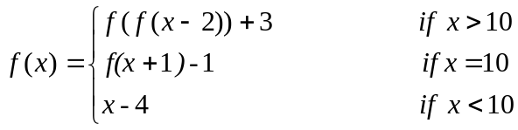
Where [n] represents the greatest integer ≤ n
- Recursive Functions
Find (10,3) given:
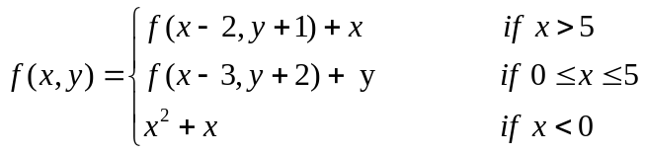

3. Computer Number Systems
Which number is the largest?

2A3₁₆ 1243₈ 678₁₀ 1010100101₂

4. Computer Number Systems
Evaluate the following expression and express the answer in octal:

101101₂ * B7₁₆

- What Does This Program Do?
What is printed when this program is run?
a = 10:b = 8:c = 2:d =-1:e = 0
if (a+2)/(b-2) = c then a = a + b
if a + c - 8 < e then c = c + b else e = e + b
if b*c > d^2*e/b then d = d * c else d = d * d
if a + c + d = b + e then c = a - d else b = a + b / 2
if e - d <> a + c then e = e / c else c = c ^ e
if (a>b) and (b>c) then a = b - c
if c / 2 = int (c / 2) then c = c / 2
print (b + d) / e + ( a + e) / b + c
end

