ACSL
American Computer Science League
2012 - 2013

Contest #3

Intermediate Division Solutions

- Graph Theory
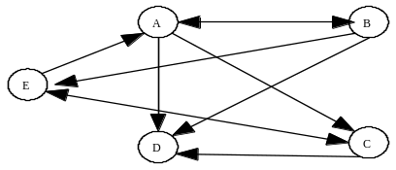 B & C and D & E

1. 2

2. 64
- Graph Theory

1 | 1 | 1 | 1 | 3 |  | 8 | 5 | 7 | 5
1 | 1 | 1 | 1 |  |  | 8 | 5 | 7 | 5
1 | 0 | 0 | 0 |  | = | 3 | 2 | 3 | 2
0 | 0 | 1 | 0 |  |  | 1 | 1 | 1 | 1

Cubing an adjacency matrix produces all the paths of length 3.
Adding the entries gives the paths of length 3.

3. 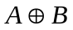
- Boolean Algebra
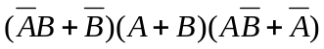=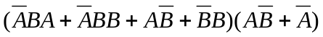
=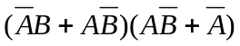=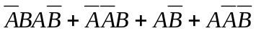=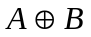

- Boolean Algebra
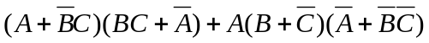
=
= 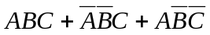

 |  |  |  | 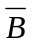 | 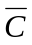 |  | 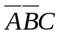 | 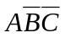 | +
0 | 0 | 0 | 1 | 1 | 1 | 0 | 0 | 0 | 0
0 | 0 | 1 | 1 | 1 | 0 | 0 | 1 | 0 | 1
0 | 1 | 0 | 1 | 0 | 1 | 0 | 0 | 0 | 0
0 | 1 | 1 | 1 | 0 | 0 | 0 | 0 | 0 | 0
1 | 0 | 0 | 0 | 1 | 1 | 0 | 0 | 1 | 1
1 | 0 | 1 | 0 | 1 | 0 | 0 | 0 | 0 | 0
1 | 1 | 0 | 0 | 0 | 1 | 0 | 0 | 0 | 0
1 | 1 | 1 | 0 | 0 | 0 | 1 | 0 | 0 | 1

4. 3

- What Does This Program Do?
This program counts the number of primes from 2 to 25.
It uses the method called the Sieve of Eratosthenes.

5. 9

