ACSL
American Computer Science League
2012 - 2013

Contest #4

Intermediate Division

1.
- Data Structures
What is the depth of the binary search tree for:
TARHEELSTATE

2.
- Data Structures
What would the next popped element be in the following stack?

PUSH(R), PUSH(A), PUSH(L), PUSH(E), POP(X), POP(X),
PUSH(I), PUSH(G), PUSH(H), POP(X), PUSH(D), PUSH(U),
POP(X), POP(X), PUSH(R), PUSH(H), POP(X), PUSH(M),
POP(X), POP(X), POP(X)

3.
- Digital Electronics What ordered triple(s) make the following circuit TRUE?
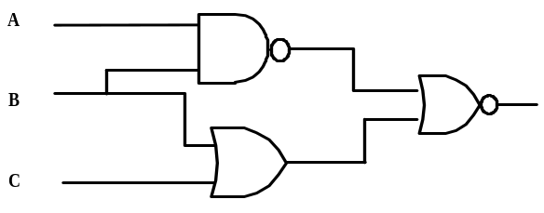

- Digital Electronics How many ordered triple(s) make the circuit TRUE?
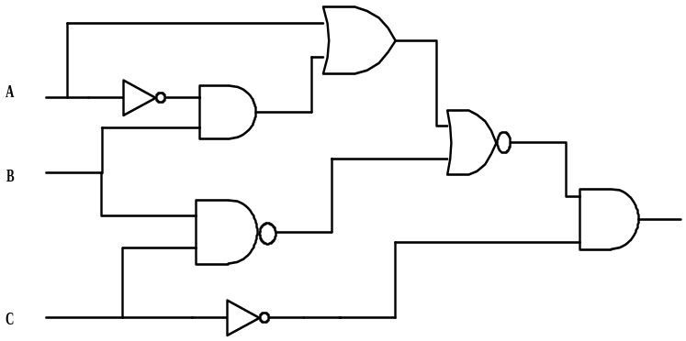
4.

- LISP
Simplify the following LISP expression:

(CAR(CAR(CDR(CDR(CDR ‘(1(2 3)4((5 6)(7 8)9)))))))

5.

