ACSL
American Computer Science League
2008 - 2009

Contest #4

Intermediate Division Solutions

1. 6

1. Data Structures
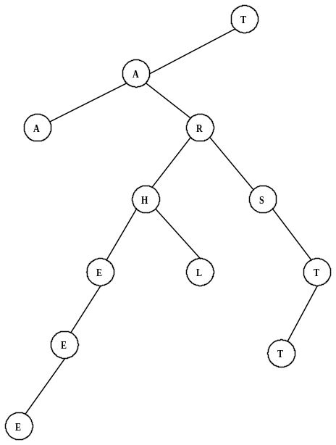

The binary search tree is shown on the right. The depth of the tree
is 6.

2. Data Structures
The stack is constructed as follows:
R, RA, RAL, RALE, RAL, RA, RAI, RAIG, RAIGH, RAIG,
RAIGD, RAIGDU, RAIGD, RAIG, RAIGR, RAIGRH, RAIGR,
RAIGRM, RAIGR, RAIG, RAI. The next popped item is I since stacks are LIFO.
2. I

3. NONE
3. Digital Electronics
The circuit translates to: 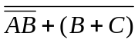
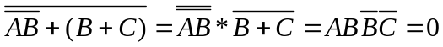
Therefore no triples make the circuit true.

4. 0
4. Digital Electronics
The circuit translates to: 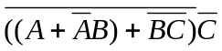
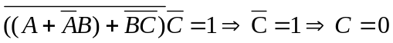
which is impossible. Therefore no ordered triples make it true.

5. LISP
(CAR(CAR(CDR(CDR(CDR ‘(1(2 3)4((5 6)(7 8)9)))))))
= (CAR(CAR(CDR(CDR ‘((2 3)4((5 6)(7 8)9))))))
= (CAR(CAR(CDR ‘(4((5 6)(7 8)9)))))
= (CAR(CAR ‘((5 6)(7 8)9)))
= (CAR ‘(5 6))
= 5

5. 5

