ACSL
American Computer Science League
2012 - 2013

Contest #1

Junior Division

1. Recursive Function
Find (100) given:
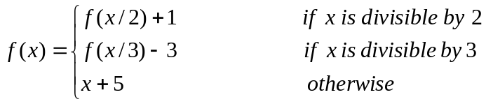

- Recursive Functions
Find (1,10) given:
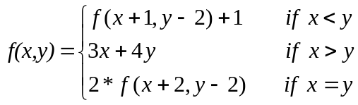
3. Computer Number Systems
Express the difference in hexadecimal.
DEAF₁₆ - ACED₁₆

4. Computer Number Systems
Convert to octal.
FACE₁₆

- What Does This Program Do?
What is printed when this program is run?
a = 20: b = 5: c =2
d = a / b
e = c ^ 2 * a / b
if e > a then a = e - a
if d / 2 = int(d / 2) then b = a / c
if b = e then e = e - 2 else b = 2 * b
if d * c < a * b then a = d - c else c = d + c
print (c + d)/a - b/a + e
end

