ACSL
American Computer Science League
2012 - 2013

Contest #3

Junior Division Solutions

- Graph Theory

0 | 0 | 1 | 1 | 1
1 | 1 | 1 | 0 | 0
1 | 0 | 0 | 1 | 1
0 | 0 | 0 | 0 | 0
0 | 0 | 1 | 1 | 0

As shown
1.

- Graph Theory

1 | 1 | 1 | 1 | 2 |  | 2 | 4 | 2 | 3
1 | 1 | 1 | 1 |  | = | 2 | 4 | 2 | 3
0 | 1 | 0 | 1 |  |  | 1 | 2 | 1 | 1
0 | 1 | 0 | 0 |  |  | 1 | 1 | 1 | 1

2. 11
Adding the second row results in 11 paths

3. Boolean Algebra
3. 

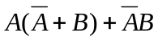= 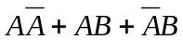
= 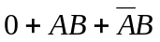= 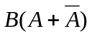=

4. Boolean Algebra  = 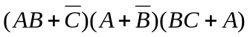

 |  |  | 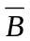 | 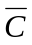 |  | 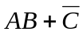 | 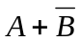 |  | 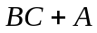
0 | 0 | 0 | 1 | 1 | 0 | 1 | 1 | 0 | 0 | 0
0 | 0 | 1 | 1 | 0 | 0 | 0 | 1 | 0 | 0 | 0
0 | 1 | 0 | 0 | 1 | 0 | 1 | 0 | 0 | 0 | 0
0 | 1 | 1 | 0 | 0 | 0 | 0 | 0 | 1 | 1 | 0
1 | 0 | 0 | 1 | 1 | 0 | 1 | 1 | 0 | 1 | 1
1 | 0 | 1 | 1 | 0 | 0 | 0 | 1 | 0 | 1 | 0
1 | 1 | 0 | 0 | 1 | 1 | 1 | 1 | 0 | 1 | 1
1 | 1 | 1 | 0 | 0 | 1 | 1 | 1 | 1 | 1 | 1

- 3

- What Does This Program Do?
This program counts the number of primes from 2 to
50. It uses the method called the Sieve of
Eratosthenes.

5. 15

