ACSL
American Computer Science League
2012 - 2013

Contest #4

Junior Division
- Data Structures
How many nodes have only one child in the binary search tree for :
DUKEUNIVERSITY

- Data Structures
Given an initially empty queue and the following sequence of operations, what would be the next POPPED element?
PUSH(E), PUSH(N), PUSH(L), POP(X), PUSH(O), POP(X), POP(X),
PUSH(E), POP(X), PUSH(H), PUSH(S), POP(X)

3. Digital Electronics What ordered triple(s) make the following circuit FALSE?
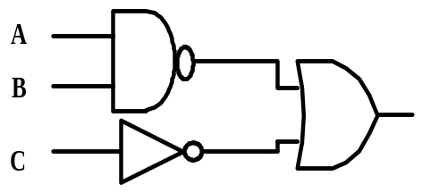

4. Digital Electronics How many ordered pairs make the circuit TRUE?
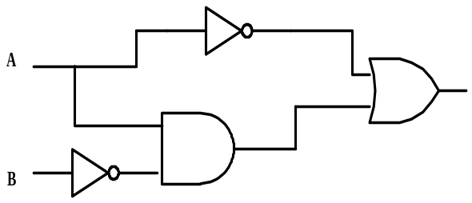

5. What Does this Program Do?
b$="": c$="": d$="": e$=""
a$="snowwhiteandthesevendwarfs"
for i=1 to len(a$)-1 step 2
if mid$(a$, i,1) < mid$(a$, i+1 ,1) then b$=b$+mid$(a$, i,1)
if mid$(a$, i,1) > mid$(a$, i+1 ,1) then c$=c$+mid$(a$, i,1)
next i
if len(b$) < len(c$)
then
for j= 1 to len(b$)
if mid$(c$, j,1) < mid$(b$, j ,1) then d$=d$+mid$(c$, j,1) else e$=e$+mid$(b$, j,1)
next j
else
for j= 1 to len(c$)
if mid$(c$, j,1) < mid$(b$, j ,1) then d$=d$+mid$(c$, j,1) else e$=e$+mid$(b$, j,1)
next j
end if
print len(d$)*len(e$)
end

3 | 2 | 4 | 5 | 1
0 | 1 | 3 | 2 | 6
1 | 2 | 1 | 3 | 4

