ACSL
American Computer Science League
2012 - 2013

Contest #4

Junior Division Solutions

- Data Structures
1. 7

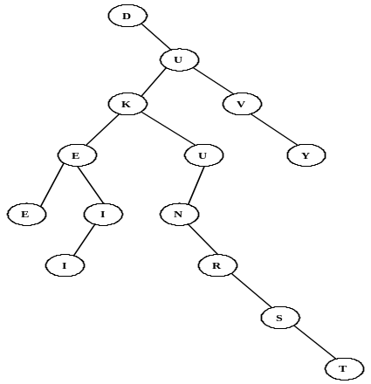

The binary tree formed is shown on the right. The number of nodes with only one child is 7.

.

- Data Structures
The queue is constructed using FIFO as follows: E, EN, ENL, NL, NLO,
LO, O, OE, E, EH, EHS,HS. The next element POPPED is H.

2. H

3. Digital Electronics
The circuit translates to the Boolean expression: 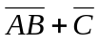
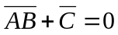→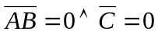→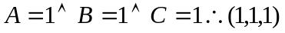

3. (1, 1, 1)

4. Digital Electronics
The circuit translates to: 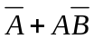

 |  |  | 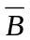 | 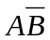
0 | 0 | 1 | 1 | 0 | 1
0 | 1 | 1 | 0 | 0 | 1
1 | 0 | 0 | 1 | 1 | 1
1 | 1 | 0 | 0 | 0 | 0

4. 3

Therefore there are 3 ordered pairs: (0, 0),
(0, 1), and (1, 0).

3 | 2 | 4 | 5 | 1
0 | 1 | 3 | 2 | 6
1 | 2 | 1 | 3 | 4

- What Does this Program Do?

The first loop compares characters in pairs. If the first one is alphabetically
first, it goes into b$, otherwise it goes into c$. The result is:
b$ = “oieeedaf” and c$ = “swent”
The second loop compares the shorter string to the longer string character
by character. If the first one is alphabetically first, it goes into e$, else
it goes into d$. The result is: d$ = “” and e$ = “oieee”.
Therefore the product of the lengths is 0*5 = 0

5. MIGCUCOAUTAI
5. 0

