- Data Structures
The resulting heap:

6. Computer Number Systems
Consider 101 in each position: 101xx, x101x, and xx1010. There
are 4 possible values for each (thus 12 in total). However 10101 will
appear twice, once as part of 101xx and a second time as part of
xx101.

6. (C) 11
5. (E) None of the above

7. (B) 12

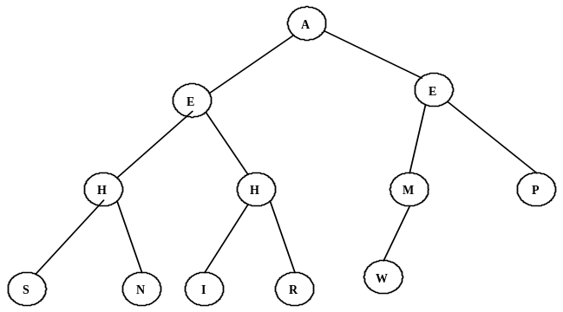
8. (D) H, H, M, P
5. Prefix-Infix-Postfix
diff / 8 2 diff + 2 1 – 4 3 ↑ 2 3 * 2 3
= diff (/ 8 2) diff( + 2 1) (– 4 3)( ↑ 2 3)( * 2 3)
= diff (8/2) diff (2+1)(4 – 3)(2³)(2*3)
= diff 4( diff 3 1 8) 6 = diff 4 (max(|3 – 1|, |1 – 8|, |3 – 8|) 6
= diff 4 7 6 = max(|4 – 7|, |7 – 6|, |4 – 6|) = max(3, 1, 2) = 3

7. What Does This Program Do?
This program manipulates the letters in the alphabet.
The “i” loop puts one letter in each cell of a$.
The “j” loop replaces each third letter with the one before and after it.
The “k” loop replaces the cells which are multiples of 4 or one more
than a multiple of 3 with a new string.
The “b” loop removes the string if the string is 2 characters and the
cell number is even.
The “d” loop removes strings shorter than 4.

ACSL
American Computer Science League
2015 - 2016

All-Star

Junior Division
Short Round Solutions
1. Boolean Algebra
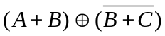 = 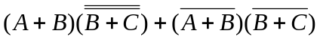
= 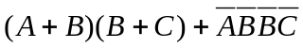 = 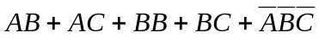
= 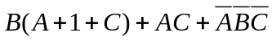 = 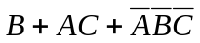
To be FALSE, all terms in the expression must be 0.
So 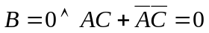.
If 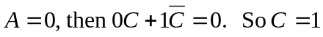. (0, 0, 1)
If 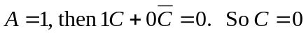. (1, 0, 0)

1. (D) (0, 0, 1), (1, 0, 0)

2. Bit-String Flicking
Let X = abcde and NOT X = ABCDE.
LHS = NOT X AND (LSHIFT-1(RCIRC-2 01011))
= (NOT abcde) AND (LSHIFT-1 11010)
= ABCDE AND 10100
= A0C00
If A0C00 = 10000, then A = 1, b = *, C = 0, d = *, e = *.
Therefore a = 0, b = *, c = 1, d = *, e = *. 0*1**

2. (C) 0*1**
3. Recursive Functions
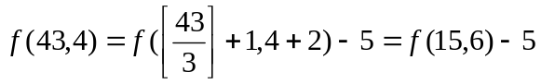= 20 – 5 = 15
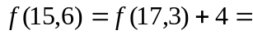16 + 4 = 20
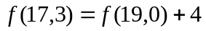= 12 + 4 = 16
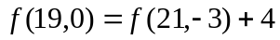= 8 + 4 = 12
0=13 – 5 = 8
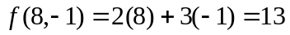
3. (B) 15
4. Digital Electronics
The circuit translates to: 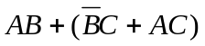
If 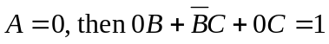.
If 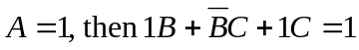.
If
If
Therefore there are 4 solutions.

4. (D) 4

